Slovenia 2026
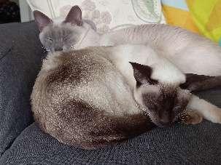
My day started by dropping the cats off at the cattery. They had been unsettled for a few days, aware that something was going on.
David & Stella picked me up at 10.45, and took me to Plymouth coach station, for the seemingly endless journey to Heathrow.
An Asian lady sat next to me & slept most of the way. ~ Lucky her!
She was on her way home to London after visiting her daughters in Plymouth.
We pulled into Heathrow on time, and I made my way down in the lift, along a very long corridor, back up in the lift to bus stop 10 to pick up the hotel Hoppa to my hotel Raddison Red. My bus was supposed to be H2C, but the driver of H2D said he would drop me off, but it would be the last stop. ~ That was kind of him. He also had a good sense of humour, as later on a party of Australians got on at Holiday Inn. He asked where they wanted to go. ~ They wanted the Premiere Inn near terminal 2, which he did not go to. He said, “get on, I don’t go there!” Holiday Inn is served only by H2D, but they didn’t realise this.
However, he offered to drop them off at a H2C stop, which happened to be my hotel, and showed them where to go. (it was walking distance).
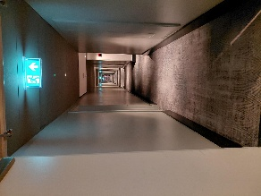
For once I was at the correct hotel (the last 2 trips I ended up at the wrong one!)
Check in was quick and easy. My room was at the end of a very long corridor. However, it was huge. My walk-in shower was nearly as big as my bathroom at home. I had a super king bed, comfy seating area, and room for a dance!
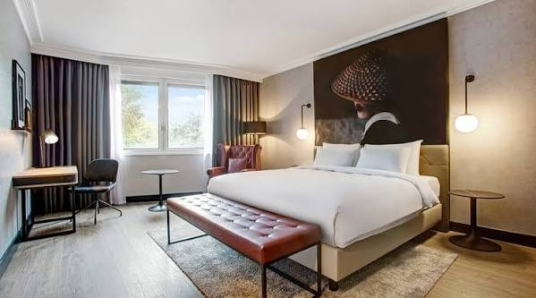
I decided to splash out and go down to the bar for a glass of wine, and also ended up having a minestrone soup, which was delicious, and no dairy. (I had eaten a chicken and coleslaw granary roll on the coach, and a slice of boiled fruit cake) I wasn’t particularly hungry but thought I ought to eat something.
After that I walked across the road to the garage to buy some Imodium. I hadn’t bought my buscopan with me as I hadn’t taken any for ages but was beginning to feel the need for it. It must be travel stress! It seemed odd to walking around in daylight. ~ I’m normally at Heathrow in the dark winter months.
I had bought a pot of overnight oats with me, forgetting I had booked breakfast, so I had oats for desert once I got back to my room.
I slept very well, and woke at 6.00am, and was showered by the time my alarm went off. Breakfast was awful! I won’t do that again. The hot food was tepid. It was constantly refreshed with hot being tipped on top of cold. The cereal was OK, but I couldn’t find any spread (not even butter) for my toast. Next time I will bring some overnight oats and not book breakfast. It wasn’t cheap either!
The traffic at 07.30am was horrendous, and taxi drivers were warning of long delays to terminals 2 & 3. Once the bus arrived and we had got out of the car park, it was easy and quick as other buses gave way, and I’m sure we ran a red light!
I was at Terminal 3 by 08.15, and my flight wasn’t until 13.00! While trying to find where my check-in desk was, I was approached by a man who was a rep for Travel-sphere, a sister company of “Just You”, the company I was going with. He wished me a pleasant journey which was nice.
A lady came up to me at 09.45 as she had spotted my luggage tag. She asked if I wished to check in early while it was quiet. (check in wasn’t until 11.00). Once through check-in, security for once was a breeze. No queues, no double checks – straight through!
Once Id walked the gauntlet of duty free shops, I had a long wait in the departure lounge before my gate was shown. I passed time reading my book and a newspaper; while eating the banana I took from the breakfast buffet.
With 20 minutes to go before our departure gate was displayed, I made a trip to the ladies. On my way back, I was stopped by a lady asking if I was going to Slovenia. ~ I was a bit surprised but replied I was. Me too she said. I’m Annette, and I saw your luggage tag. Thus began a good friendship.
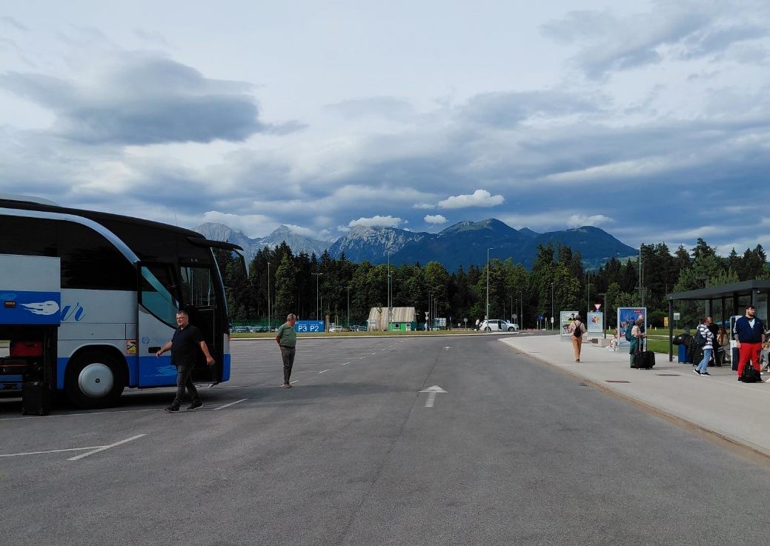
The flight out was a little bumpy, but after 2 hours I the air we landed at Ljubljana.It was so small!

We were soon greeted in the arrivals hall by Matej, our tour director. Once we were all accounted for, we made our way to the coach and our driver Peter.

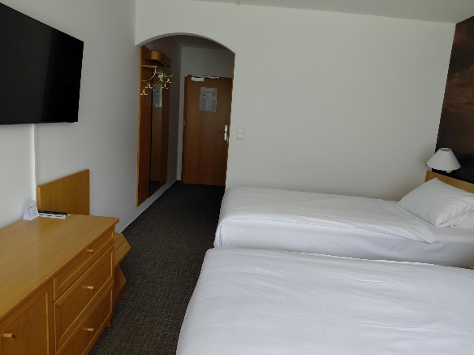
Ljubljana means “My beloved”. I sat next Annette on coach for our journey to Kranjska Gora, high up in the Julien Alps. On the way Matej kept up a witty commentary telling us about the history of Slovenia, which was part of Yugoslavia for most of the 20th century. As part of Yugoslavia, Slovenia came under communist rule for the bulk of the post-World War II period. With the dissolution of the Yugoslav federation in 1991, a multiparty democratic political system emerged. Slovenia’s economic prosperity in the late 20th century attracted hundreds of thousands of migrants from elsewhere in the Balkans. In the early 21st century, Slovenia integrated economically and politically with western Europe, joining the North Atlantic Treaty Organization as well as the European Union.
My hotel room was on the first floor, and of generous size with a balcony. I had to go to reception as I didn’t have any towels in the room.
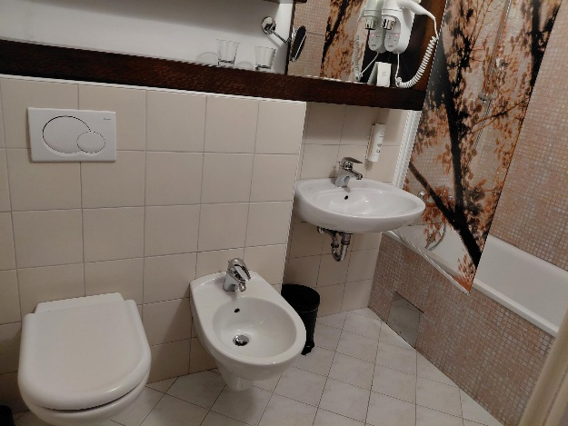

We met before dinner at the bar, where I had a glass of Pinot noir (I’m not normally a white wine drinker, but Matej said the red wine was “rough”) One lady didn’t heed his advice and said it was virtually undrinkable! Beer seemed the drink of choice. We were also given a welcome glass of Blueberry schnapps, which was gorgeous.
Dinner was a buffet style, with vegetable soup, a choice of main dishes, (many of which were local) and a small choice of desserts. Coffee was not available after the meal unless it was purchased at the bar.
The bedroom, when I returned, was very warm, so I opened the balcony door. Later we found out that as well as radiators, the hotel had heated floors and walls. …. The heating was on and started pumping round at 03.00am!
Day 2 Wednesday
I had a terrible night. I was dehydrated, hot and beyond tired. It rained heavily all night and there was an impressive thunderstorm at 04.30. I was just dropping off to sleep when the delivery vehicles arrived at the kitchen at 06.00. I gave up and had a shower. ~ not a powerful one, just enough water to shampoo my hair. There were no tea making facilities in our rooms, so as soon as I was dressed, I went down to the dining room for breakfast and a much-desired coffee.
I was the first in our group down. Breakfast was a buffet~ cereal, juice, fruit, bread and hot dishes, but no toast!
I was soon joined by John and Adrien, before a few ladies filtered down, all complaining of a bad night. The view from my room
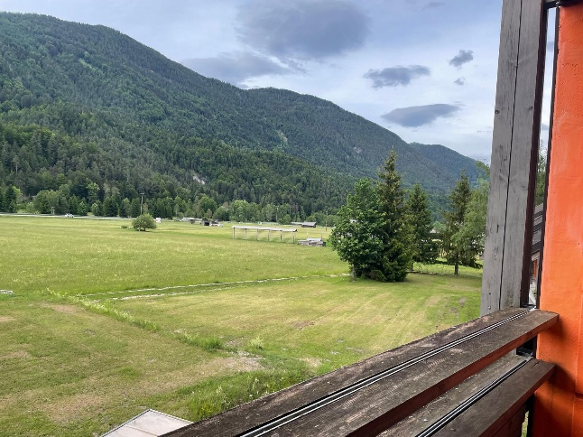
Regaining my room, I decided to charge my phone, as Matej had linked us all to WhatsApp so we could stay in touch, view the days programme and share photographs.
I couldn’t find my adaptors! The hotel is dated, and is pre-war, with no USB sockets. The heating is controlled centrally, so we couldn’t turn it off. Great for drying socks and undies, but what a waste of heat. I think we were all sleeping with the balcony doors open. I hired an adaptor from the hotel for a deposit of E10. Crisis averted!
The cleaning lady came round before 09.00am, so I moved myself downstairs. On my way out, I noticed her on her hands and knees washing the bathroom floor! Obviously things are done the “old fashioned way”.
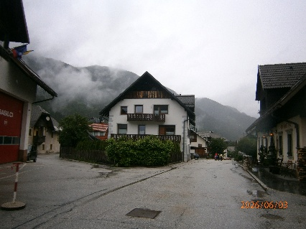
We were due to go for a walk this morning, followed by a visit to the Liznjek Homestead (which is a museum). Because of the heavy rain Matej switched the visits round, as he thought the rain would ease.
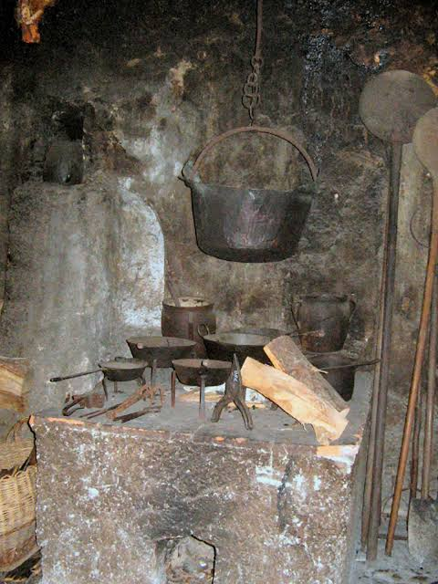
In the more than 300-year-old Liznjek House we walked through the wooden house with black kitchen with bricks thick with soot, a wide lobby and a small room which was heated by a ceramic oven; the back of the fire in the “black kitchen”. Climbing up to the attic to two wooden bedrooms called “štibelc” and descend to the cellar called “čevder”, where the toilets were. Originally where animals were held during the winter.
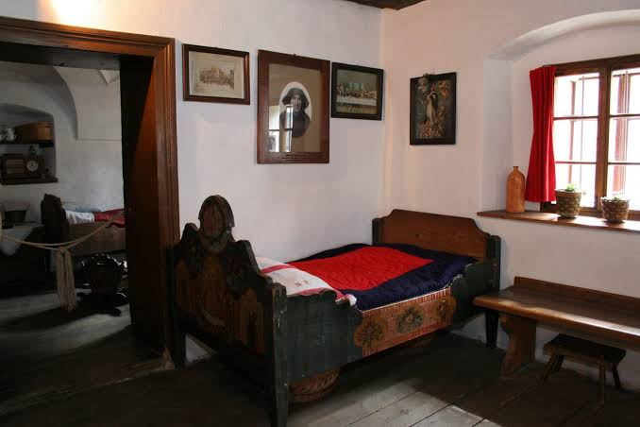
The house is characterised by paintings on the façade, a stone arched portal and wooden balcony called “gank”. In 1983, the Liznjek Homestead was restored and turned into a museum.
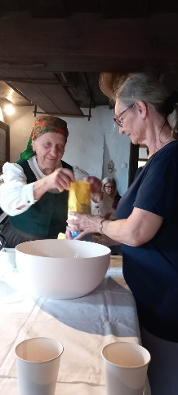
Originally the house belonged to a rich family, depicted by the pictures on the walls, and 2built in cupboards; 1 for the man of the house where the alcohol, money and tobacco were kept; and one for his wife where the best china was kept. They were both kept locked. The tables had removable tops, and inside a storage area they kept household goods.
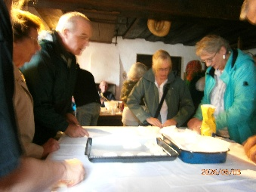
We had a bread making session, making small rolls one for each of us. In my view it needs more seasoning. Dee volunteered to knead the dough.
We also visited the barn, where wooden tools were kept, stored, made and repaired.
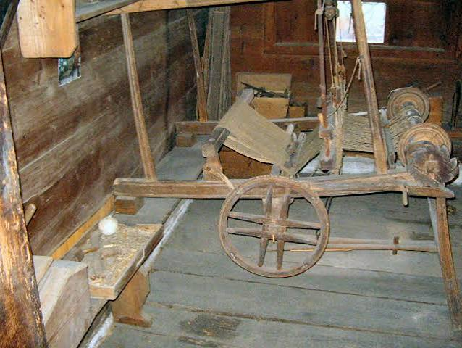
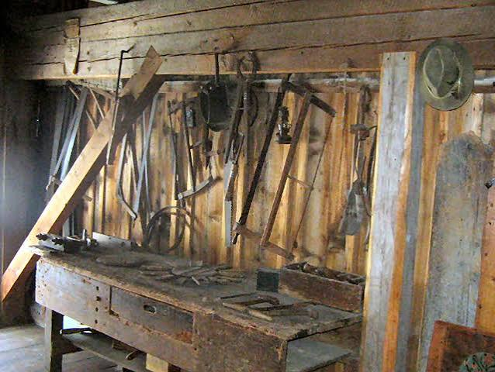
Eileen had a go at walking on stilts but toppled over, and Matej muttered “Oh no, paperwork”.

After the museum, 5 of us went looking for lunch. We ended up at a restaurant opposite our hotel. Most of us had soup. The speciality is mushroom soup served in a bread bowl.
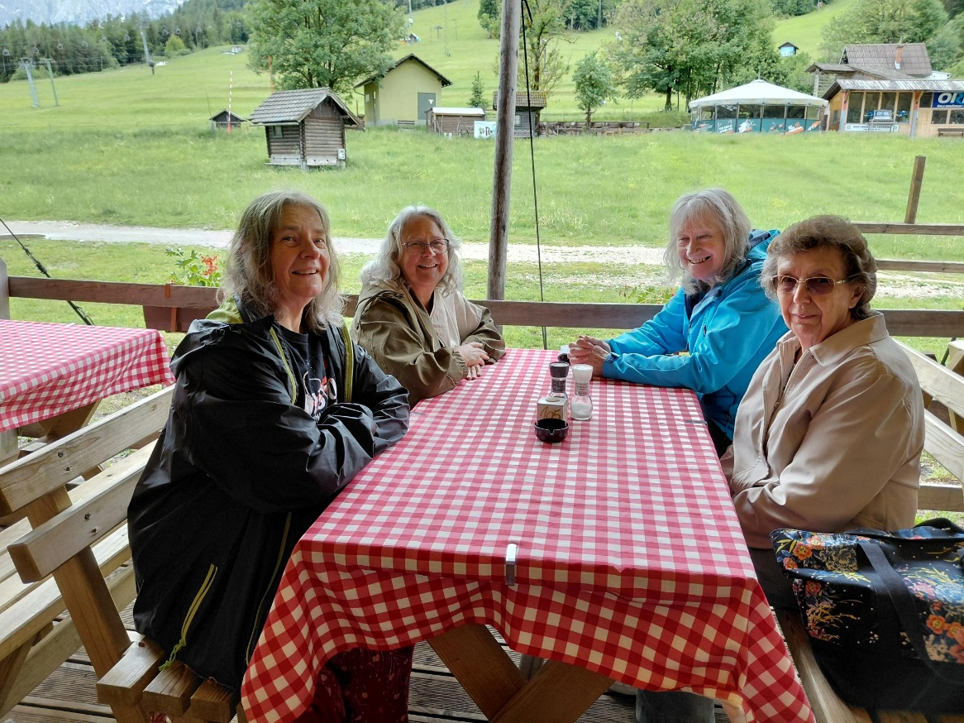

L to R Tracey; Annette, Anne & Ann
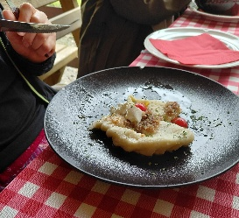
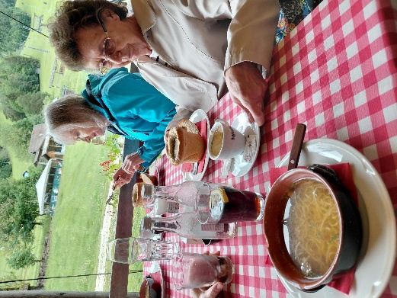
Annette and I had beef soup with noodles, while Tracey had Dumplings with lard, which she said was very nice.

After lunch we explored the hotel complex which had a pool, jacuzzi and sauna which is open 9-7.
Then at 3pm we met Matej in reception for a walk to Jasna Lake for a coffee. In the centre of Kranjska Gora, we walked through the Park of Peace with an exhibition of photographs showing the construction of the road to Vršič mountain during World War I.
The Park of Peace was established on the occasion of the 100th anniversary of the Russian Chapel under Vršič.
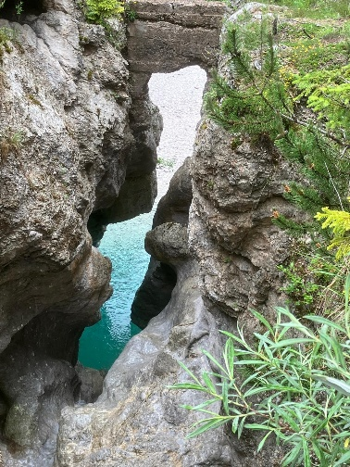
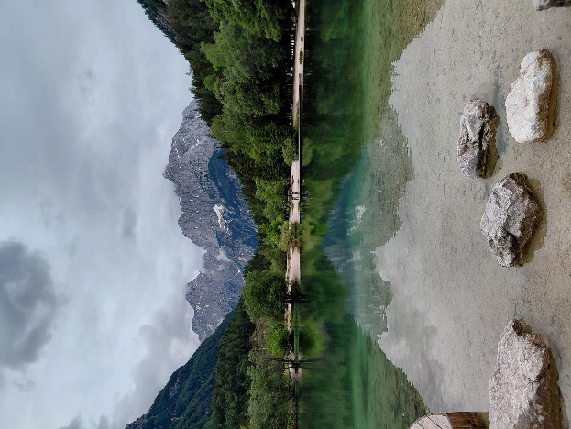
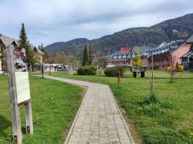
The Park of Peace presents the events of war time on boards, and there is also an entrance map – a map of the Road to Vršič with markings of the facilities that were or were used by the army for the supply of supplies to the front line of the Battle of the Bulge. Photographs taken during the construction of the road were provided by the Austrian National Library.
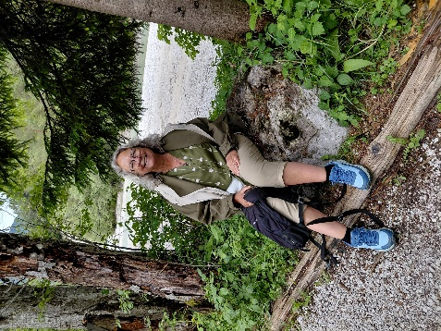
Annette

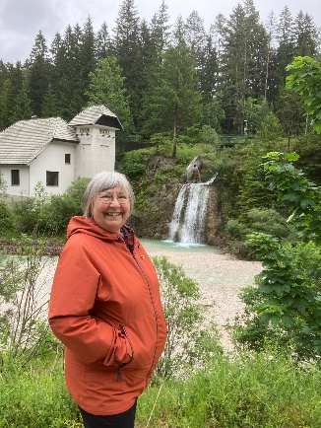

The walk along the river was pretty, with lots of gorges carved out by water over many years. In the background of this picture of me is an electricity generation station.

After having sat for 2 days travelling, I knew I had done the walk! It was only 4km.
Arriving back at the hotel, we had 1.5hrs before dinner, so I put my phone on charge, updated my diary, and had a short read; Annette and Tracey went for a swim.
Dinner was once again a buffet, but quite tasty, and conversation was flowing freely.
I went to my room at 9pm as I had hit a wall of tiredness. The room was much cooler, as the door had been open all day. I slept well.

Day 3 Thursday
What a difference! I woke to sunshine. We needed to be ready to board our coach by 9am. Today we are spending the day outdoors, enjoying the spectacular scenery of the Julien Alps and breathing in the clean mountain air. We are in the Triglav National park, and today we are going straight up through the middle of it into Italy, then turn right and re-enter Slovenia.
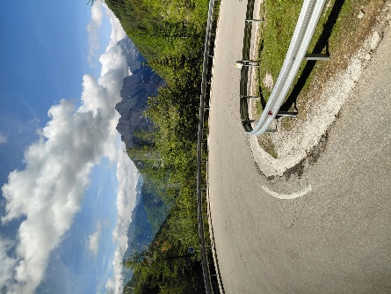
We drove up through the Sava valley where we had walked the previous day and started the ascent of Vršič mountain. It was very steep, and where we met cars they had to give way to us, in some cases reversing up and round hair pin bends.
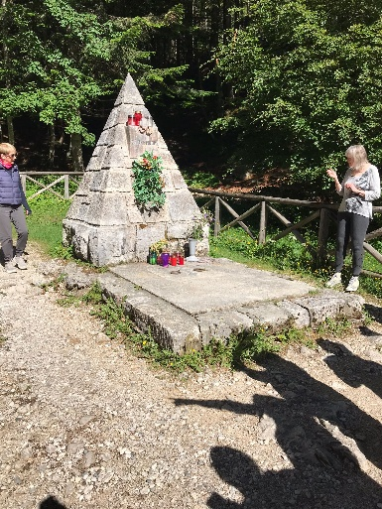
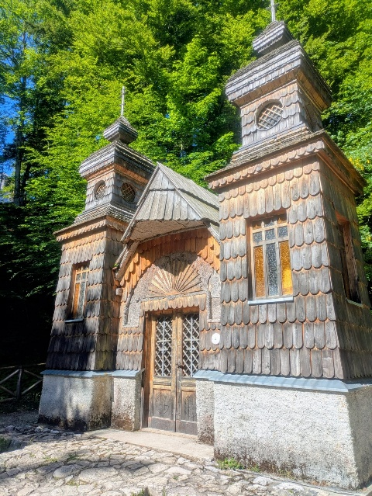
Our first stop was the Russian Church. The Russian chapel was built to honour the memory of those who died and to serve as a reminder of the follies of war. Russians prisoners built the neat little wooden chapel between 1916 and 1917. The chapel has two small towers built in traditional Russian style. All around the chapel and along the roadside are the graves of Russian soldiers. In the First World War Vršič was a strategic point providing the Austrian troops a more accessible router to the Soča Front. The supply of arms was crucial and the road to Vršič had to be kept clear at all times, including during the winter months. Therefore, in winter, huge amounts of snow were cleared from the road by Russian prisoners of war under close supervision of the Austrian army. One day a huge avalanche buried the Russian prison camp, killing more than three hundred Russian prisoners and ten of their guards.
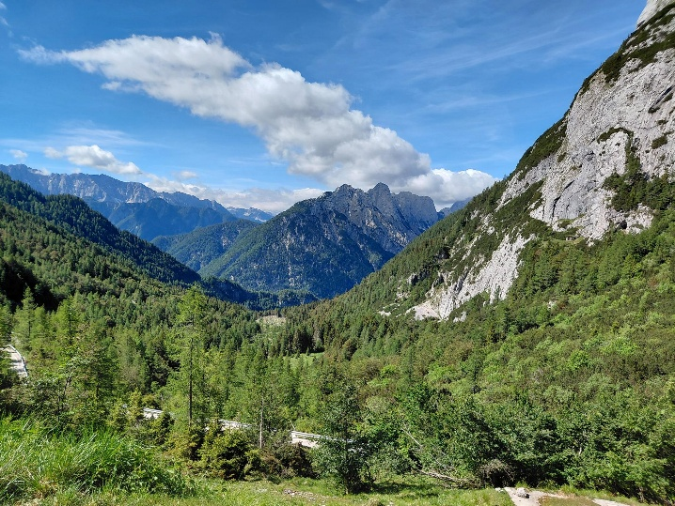
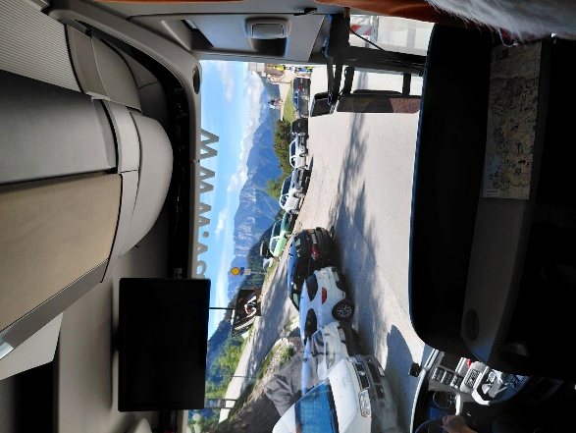
The road has some construction going on as it is due to become a toll road because it is so popular. We continued on to the mountain pass, where we could stretch our legs and visit the loo.
The views were superb.
The pass is at 1,611mtrs
The entire Vršič Pass route (which connects Kranjska Gora to the Soča Valley) has a total of 50 hairpins. The 24 turns from the Kranjska Gora side are notoriously steep and are often paved with cobblestones. Our Coach driver needed nerves of steel as the hairpin bends are tight to negotiate.
We descended into the horseshoe shaped Trenta Valley, driving along the shores of the emerald green Soca river.
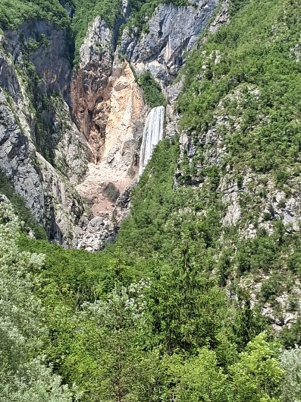
We then did a detour to visit Slovenia's highest waterfall; Boka Falls, plunging a dramatic 144 meters total, with a massive initial drop of 106 meters.
It looked as though it was coming out of a letterbox.
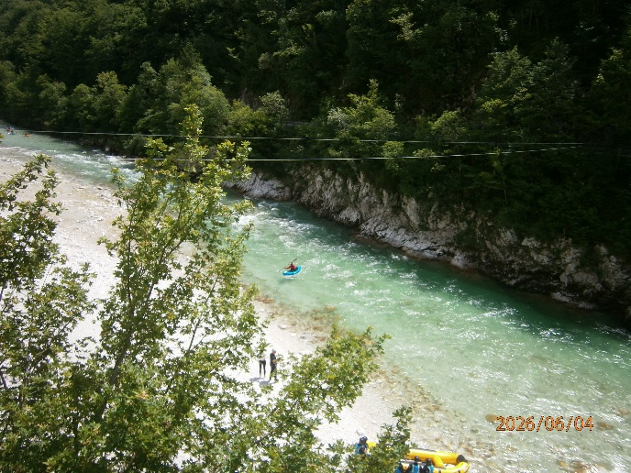
We were able to watch canoeists on the river below

The water in Slovenia is an incredible colour, and so clear.
Back on board the coach, we drove to Bovec and our lunch. We took over the entire restaurant. Our starter was cheese and potatoes (2 types of sheep’s cheese, cottage style cheese and a harder version) Matej had my cheese and I had some of his new potatoes. I didn’t dare try the cheese as we had several more hours on the coach. Main course was either a stew or pork. I chose Pork. It was delicious, and so tender. For me desert was lactose free chocolate ice cream. Yum!
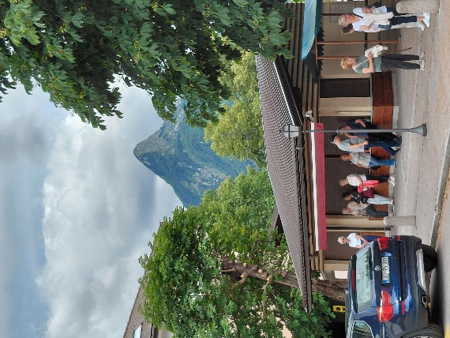
The beautiful River Soča was the location for many of the scenes in the 2008 film 'The Chronicles of Narnia: Prince Caspian' - it's so blue it could pass as a tropical sea. Bovec has views of “Narnia” Mountain. Again named because of the filming.
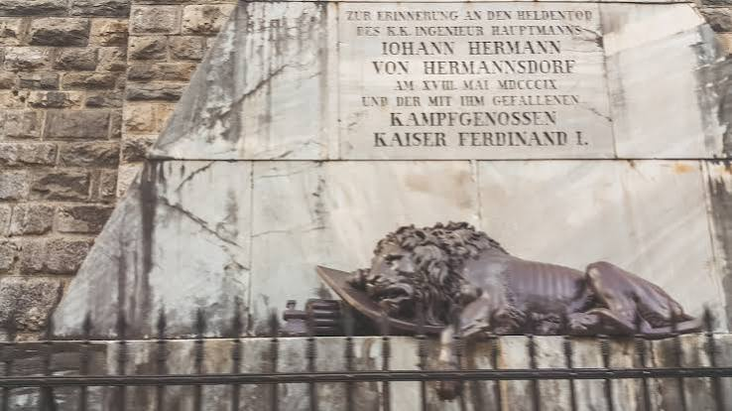
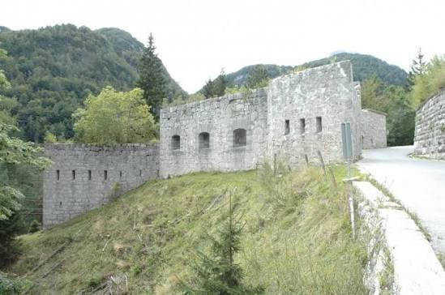
We then travelled across the border into Italy, and up a parallel valley with more amazing views. The Predil Pass monument is a tribute to the Austrian troops killed defending the nearby Predil Fortress against Napoleon’s army in 1809. Located on the mountain pass straddling the modern-day border between Italy and Slovenia, it features a striking cast-iron sculpture of a dying, "sleeping" lion atop a stone pyramid.
We then turned off into The Planica Nordic Centre which is an exceptional environment for continuing the tradition of ski jumping and flying, for training and competitions of cross-country skiers.
Planica is synonymous with courage, innovation and development. With more than 40 world records, it has become a spectacular attraction that also attracts many foreign visitors. Edie the Eagle has jumped here, and still visits.
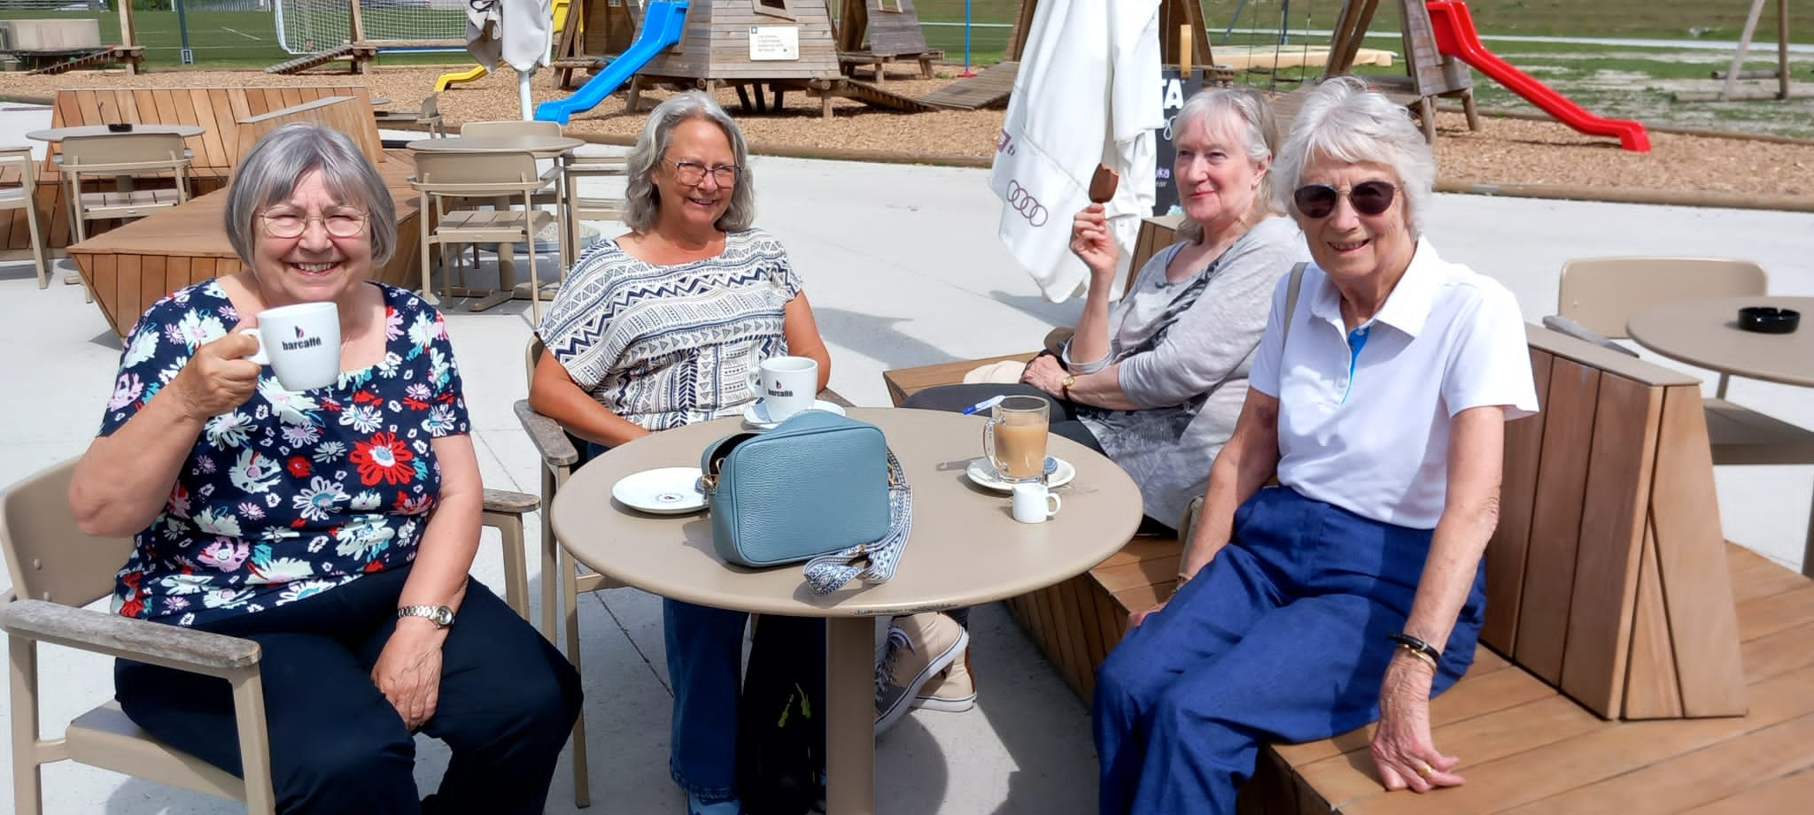
The Giant Hill (Letalnica) is one of the largest ski flying hills in the world, allowing men and women to reach jaw-dropping flight distances exceeding 240+ meters. We sat enjoying a coffee watching tiny children learn in the baby jumps.
The jumps are used all year round by lining them with plastic and spraying them with water.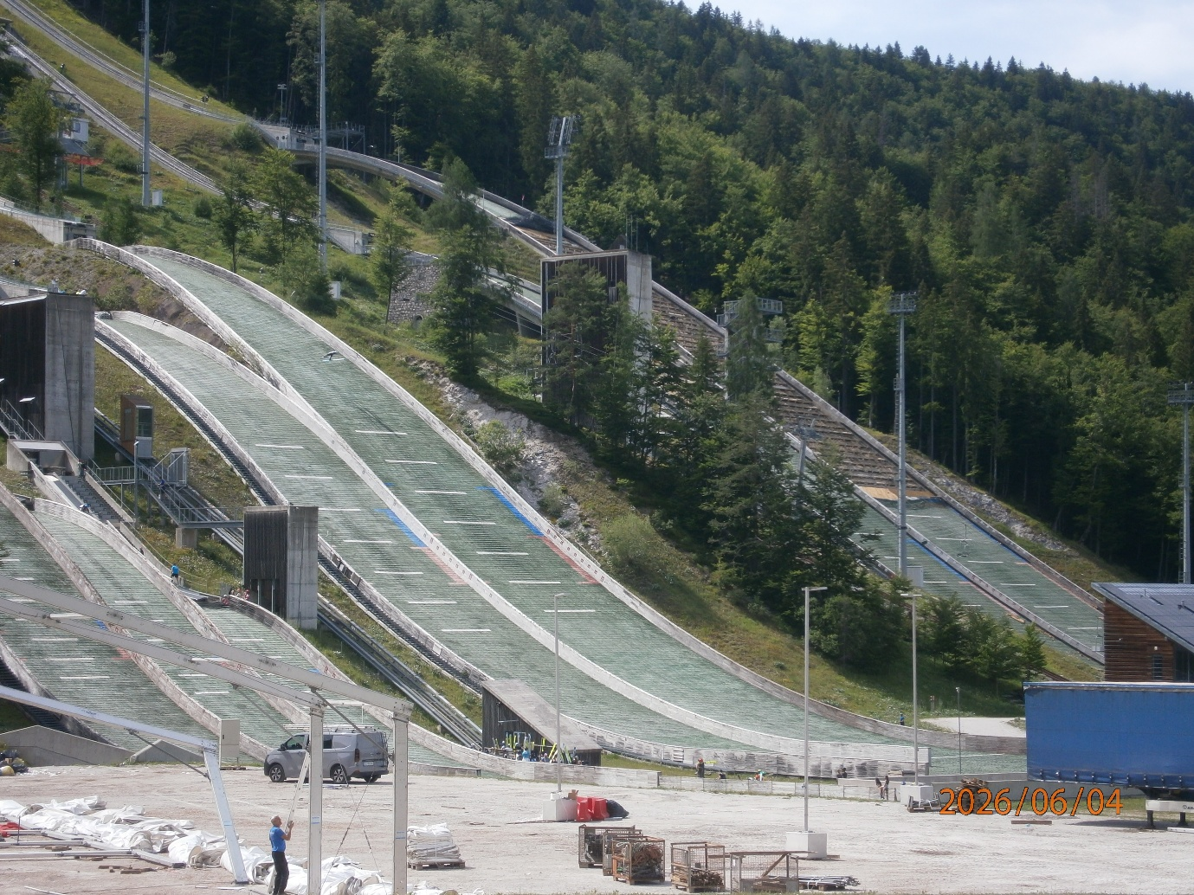
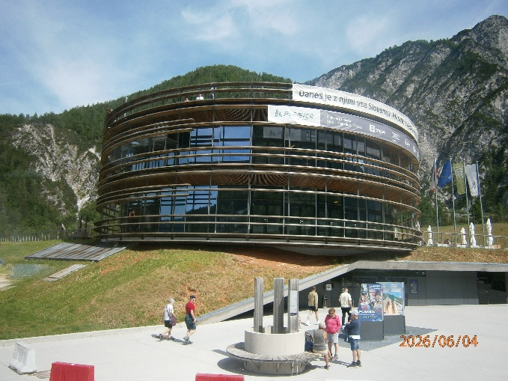
The indoor snow field and restaurant is inside this amazing building.
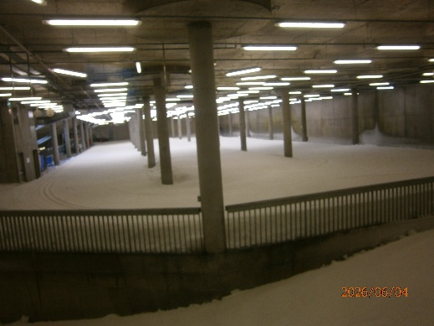

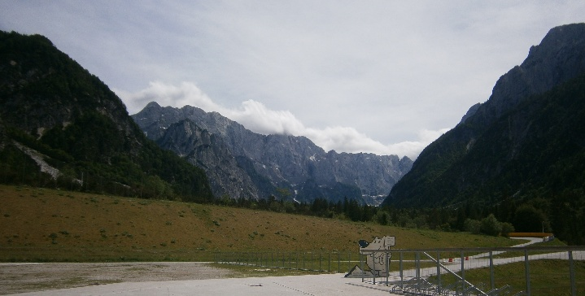
This is the view from the terrace where we had coffee
Just 10 minutes drive from the ski jump area was our hotel. We were all surprised it was so close.
On our return I sat in the sun on my balcony and rested my foot.
I discovered a new drink; “Cockta” it is an non-alcoholic drink made from rosehips, lemon, orange and 11 herbs. It tasted of caramel, and is a local version of coke a cola.
After dinner, a light one of soup and apple strudel, a group of us walked up to the church, as the locals had been setting up seating for a concert in the square. However, by the time we got there it was over!
We had walked dinner down anyway, and found out that it was E49 to hire a bike all day (electric of course) ~ a possibility for our free day.
Day 4 Friday
We woke to a wet day. Today we are going to Ljubljana, Slovenia’s capital. It is a compact crescent shaped city, with a river running through the middle.
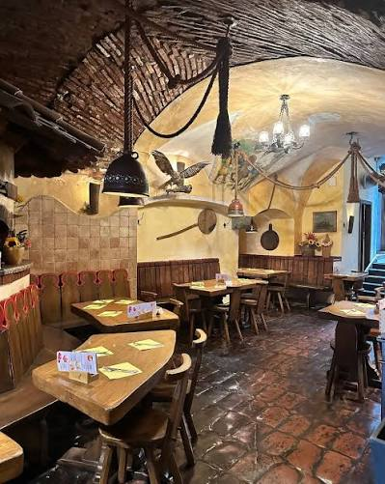
Karin, our guide, told us the history of Slovenia while we were driving there .It was information overload, and after a while I zoned out. On arrival we dashed off after Karin as she pointed out the highlights (mainly the toilets) and showed us where to meet for a trip on the river. We had time for a quick lunch in restaurant sokor, which Matej recommended.
Gostilna Sokol is located in an old townhouse in the very centre of Ljubljana. Its interior is decorated in the style of traditional rural gostilna-style restaurants and adorned with 19th century paintings. The restaurant offers traditional dishes and a choice of Slovenian wines served to the sound of Slovenian music by waiters dressed in national costumes.
House specials include mushroom soup in a bread bowl, Carniolan sausage, and homemade draught beer.
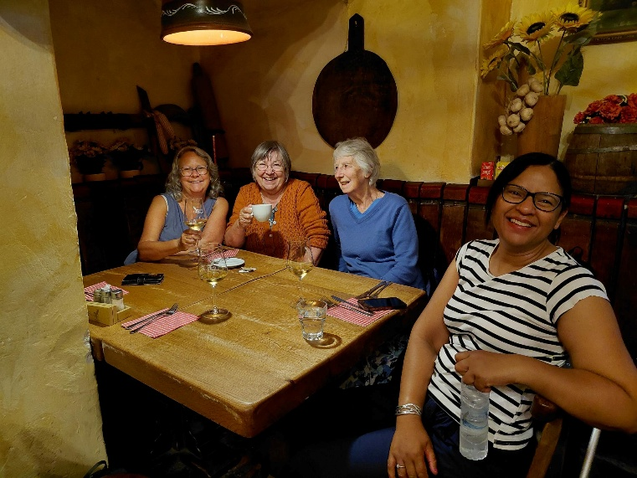
Annette, me, Ann and Michelle.
I had beef soup again, as the mushroom has dairy in it. However it was really tasty, with a trace of carrots as well as the noodles.
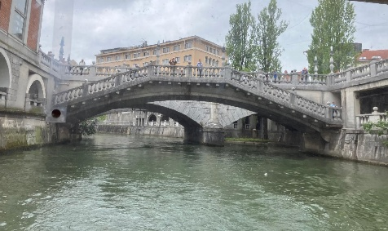
On the way to the boat, Annette and I visited a shop which sold brandy, chocolate and olive oil. We tasted a few types of schnapps, promising to come back after our river trip. The local red wine liqueur was really really nice! It was Christmas in a glass!
The river trip was OK, just down to the marshes, which was a protected area, From what I understood it was a nature reserve. Boats with engines were not along here; so we did a U turn, and went through the city centre a little before turning back to the jetty.
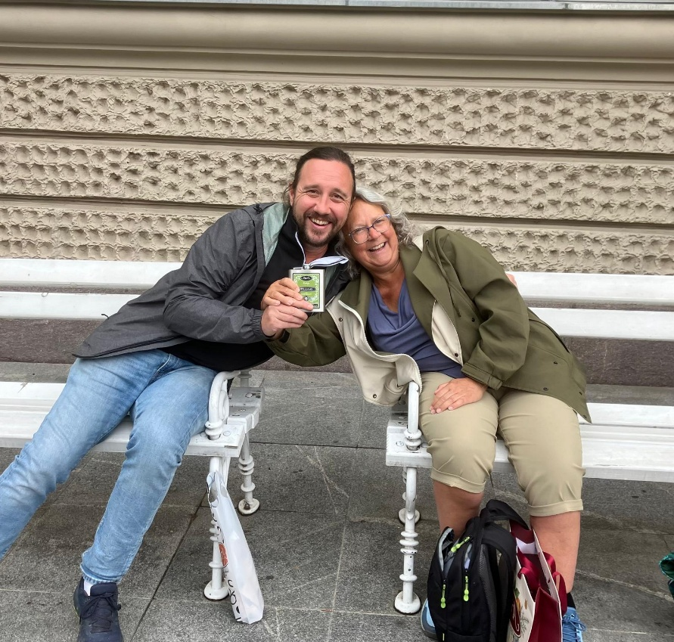
Keeping our word we returned to the brandy shop, with a large number of our group who were tempted by free tastings. The honey schnapps was uggh! Very dry. The blue berry was nice though. Annette and I didn’t like the herb one either and had to have another red wine liqueur to take the taste away!. We then wandered the touristy gift shops, most of which sold tat, before making use of the free public loos, and wandering back to our meeting point.
Matej was already there, and we sat chatting and drinking his Williams pear Schnapps.
One by one the majority of our group joined us, and our driver illegally parked to pick us up near our meeting point. We were just about to drive around the block when the remaining 4 sauntered up.
Once back on the coach the heavens opened. We settled down for our drive back.

One lady near us was scrolling through videos on Facebook. Annette and I thought she might be a tad deaf and was unaware the sound was on, and we could hear the squeaky voices of the cartoon characters she was looking at. ~ We started giggling, then she watched another clip with dramatic music ~ Dun Dun Dun! And we were laughing out loud. Matej turned round to find out what was funny, which made us laugh even more. By this time we had woken the coach!
The rain had eased by the time we got off the coach. I went and got changed from my waterproof trousers, and a few ladies went into the village for a coffee.
Once reconnected to the internet I had a message from Mums carers to say she had been found on the floor in the morning and had been taken to hospital to be checked over. They said no need to worry, they would keep me informed.
Dinner was nice Meat loaf or chicken with crushed potatoes and mixed veg, preceded by the usual vegetable soup or clear beef soup.
Day 5 Saturday.
It is Matej’s day off so we have a free day. Annette & I decided to bin our idea of hiring bikes as there was a red bull Pony bike race taking place which started outside our hotel. ~ It looks like it is going to be very busy judging by the number of camper vans in the car park. ~ The hotel is full to bursting too.
So we decided to get the 09.20 bus to Radovlijica, a medieval village.
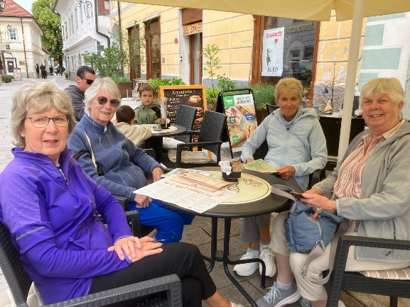
We followed ourselves on google maps so we knew when we got there.
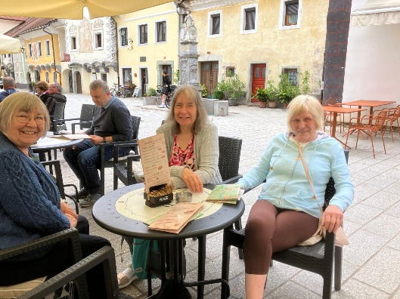
First stop was a coffee and toilet at a very nice restaurant that had the most delicious display of cakes (we managed to abstain!)

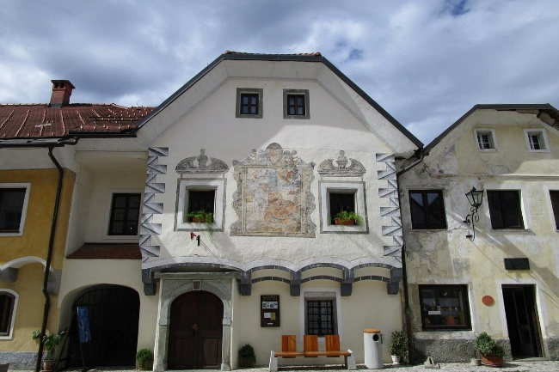
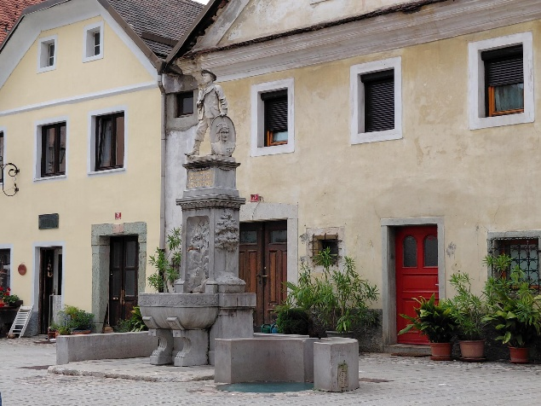
Linhart Square is situated on a promontory above the Sava river and is akin to an open-air museum. There are preserved houses from the 16th, 17th, and 18th centuries. At the viewpoint at the end of the square there are wonderful views of the Sava river valley and the Julian Alps. The old town centre of Radovlijica is enriched by numerous museums, galleries and restaurants. During a stroll through Linhart Square we visited: The Lectar Honeybread Workshop and Museum Radovlijica Manor The Šivec House Gallery.
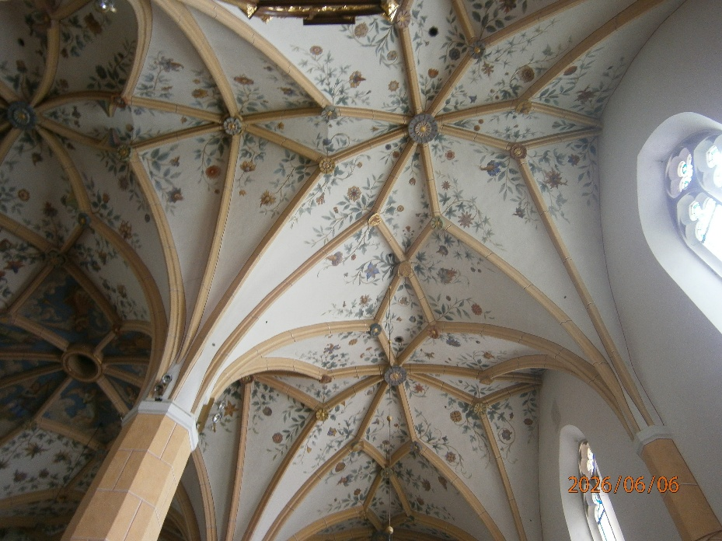
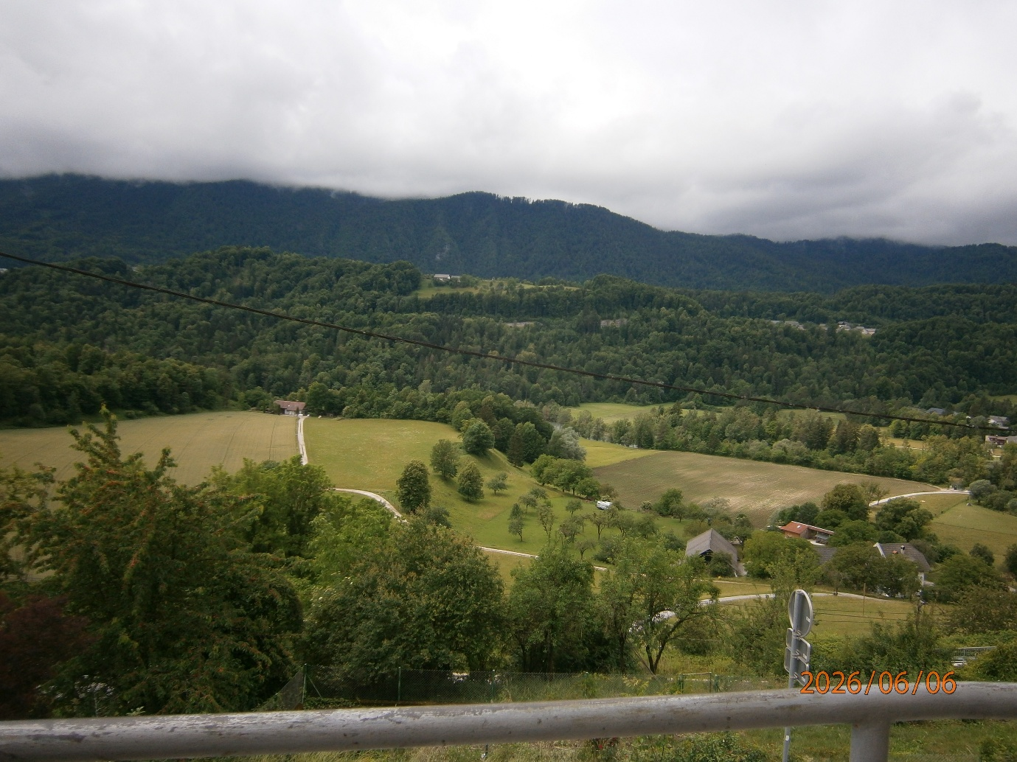
Picture from the view point The Museum of Apiculture and Municipal Museum; The viewpoint at the end of the square The square in front of the church with a small market selling honey-based products; St. Peter's church and the surrounding walls The rectory Magušar's House and Manufaktura Farmacy and Alchemy Museum.
St Peters Church was beautiful. The simple exterior appearance of the church dates from the end of the 19th century, when, due to stylish conformity, the church was restored to its original gothic form. The facade, the stain-glass windows, the entrance portal and its embellishments were renovated.

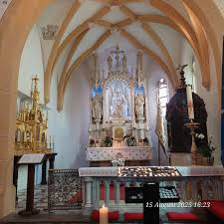
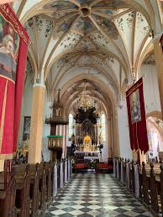
On entering the church you step into a hall, which is divided into three by pillars that support the ribbed vault, made up of an eight-point star. The vault of the central nave is embellished with an angel star. The presbytery also has a high star-shaped vault with figurines.

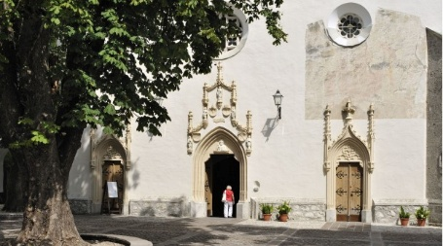
In the Lady chapel, I lit a candle for Mum.

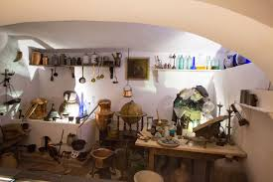
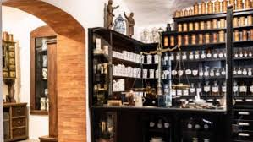
The Alchemy Museum was really interesting. On entering the ground floor of the building in Linhart Square you are transported back in time. Furniture from old pharmacies, where the shelves are filled with wonderful ceramic containers, alchemistic laboratories and old scales are merely a small part of this extensive collection at this unique, independent museum dedicated to pharmacy and alchemy.
The exhibits in the museum are the result of 40 years of collecting objects related to pharmacy, cosmetics and alchemy from all over the world. There is a museum shop which is equipped like an old pharmacy. In the shop, in addition to natural cosmetics, there are also souvenirs with mythological themes, herbs, essential oils, and a range of teas.
The chocolate shop was nice and the smell very tempting.
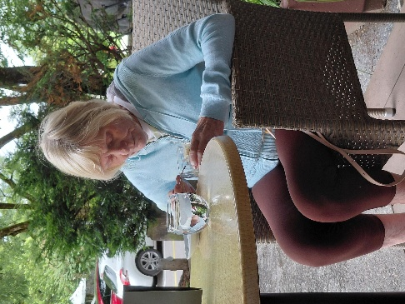
Before we got the bus back to Kranjska Gora, Annette Caroline &I stopped for coffee. Caroline tried an Affogato (coffee poured over a scoop of ice cream). We had never seen an ice disappear so fast! ~ Apparently Caroline liked it!
It cost E3.70 for the bus back to our village. Once we got there we were hungry, so the 3 of us went to the nearest restaurant, which happened to be a pizza restaurant. I had a small spaghetti Bolognese, Annette & Caroline had pizza, and saved half for lunch the following day.
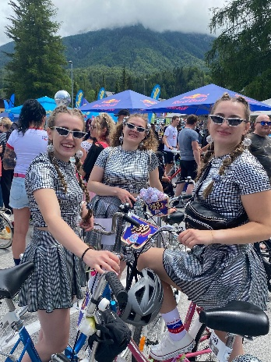
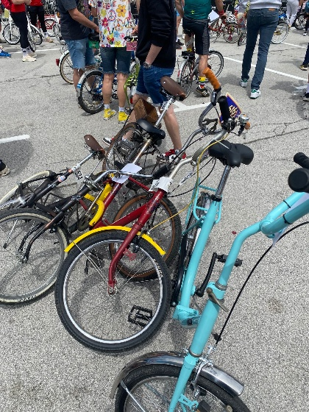
Back at our hotel, we were in time to see the tail end of the racers in the Red Bull Pony race. (Original Pony bikes with no gears). Every year in June, Kranjska Gora hosts a retro festival. In 2026 Pony bike enthusiasts tackled the vršiška serpentines for the twelfth time. The current record on the 13.5 km course is 39 minutes and 10 seconds. The finish line is set at the top of the Vršič Pass. The Red Bull Goni Pony is not an ordinary cycling competition but a competition with style that was popular during the production of the Rog Pony from the mid-1960s to the mid-1980s. Contestants dressed for the occasion too.
I sat outside for a while with some of the ladies, but it cooled off quite a bit by 5pm, so we all retired until dinner time.
Day 6 Sunday
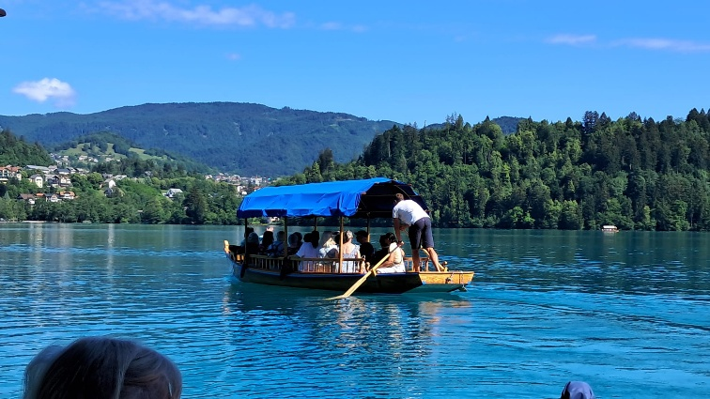
I am so tired. My room, and also Annettes 1 floor above me, overlook the service area. The hotel was clearing away from the Red Bull party at 2am, dragging stuff and talking loudly, with vehicles with their reversing beepers sounding. It quietened down until 4.00am when the delivery vehicles started to arrive. Other guests heard drunk people returning from the party. ~ I don’t know which is worse!
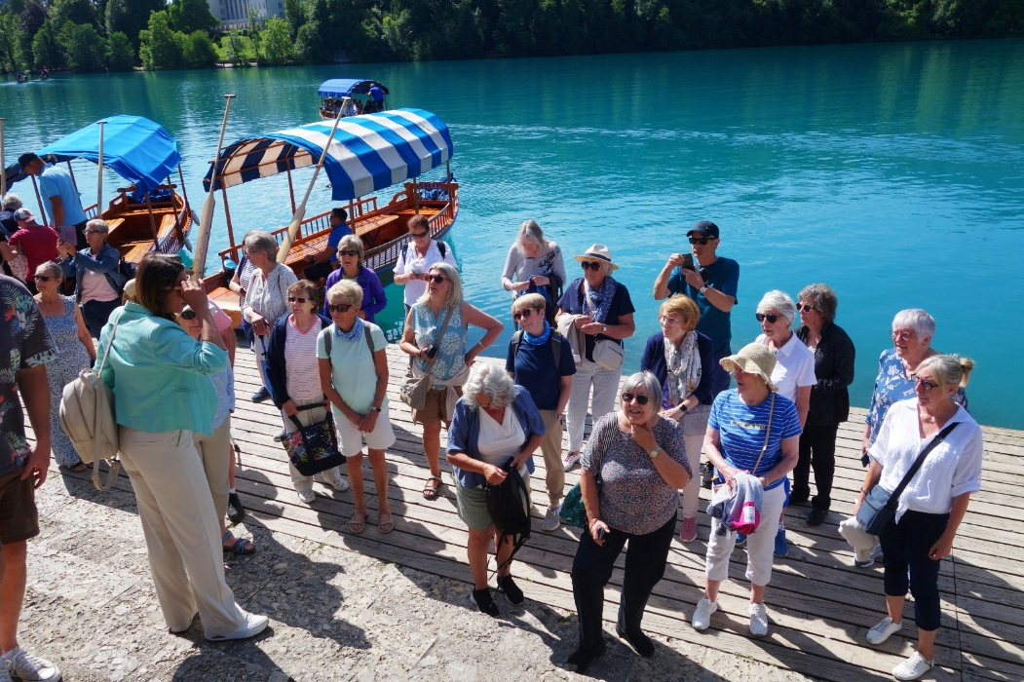
After a coach ride to Bled, we started the day with a lovely boat ride to Slovenia’s only Island. We went across in a traditional Pletna boat, which is made from wood and flat bottomed. To even out the balance we had to sit on opposite sides as we boarded it; ie right, left, right, left. If we moved to take a photo, they tipped. They are propelled by oars. No engines are allowed on the lake. With its iconic fairy-tale church steeple perched atop the tiny rock island at the middle of Lake Bled, Bled is a sight that stays in your memory. The church and other buildings, such as the wall and monumental staircase with 99 steps, have preserved their image since the 17th century. A special feature is the wishing bell in the upper roof above the church nave.
We’ve yet to climb up.

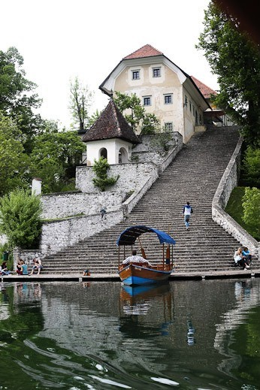
Internet photo as I forgot to take one of the steps!
Once at the top, Annette needed to sit down as she had an asthma attack climbing up. It was steep.
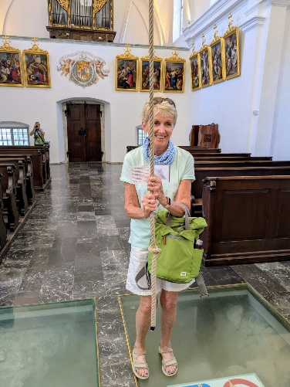
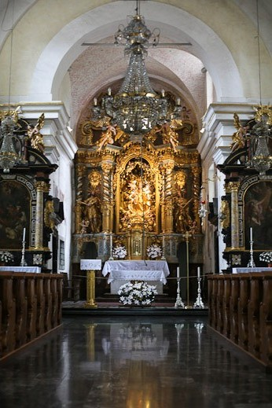
Some of our party went into the church and even rang the “wishing bell”.

It was then time to go back across the lake to our coach. It is a stunningly beautiful place, and I am so glad I came.
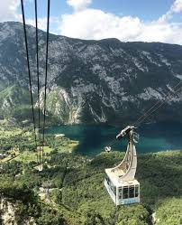
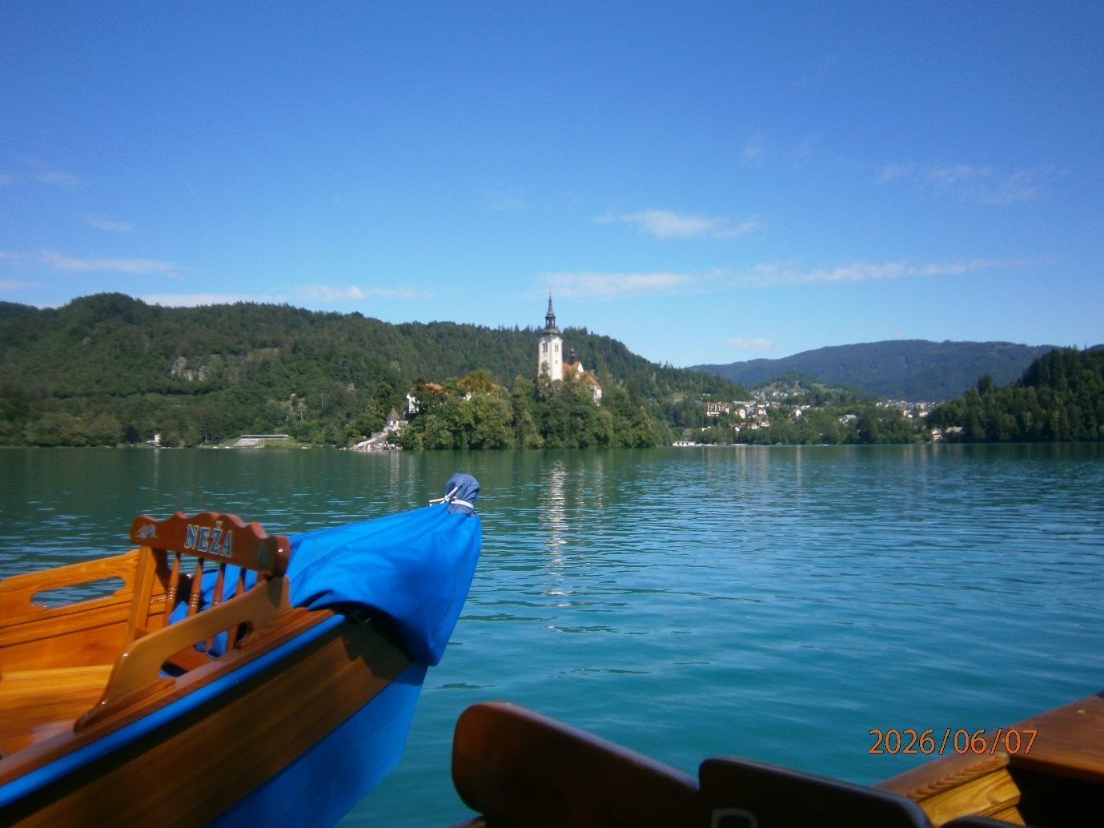
From Bled we drove up to Vogal Mountain which is 1922-meters-high.
Photograph of cable car from internet
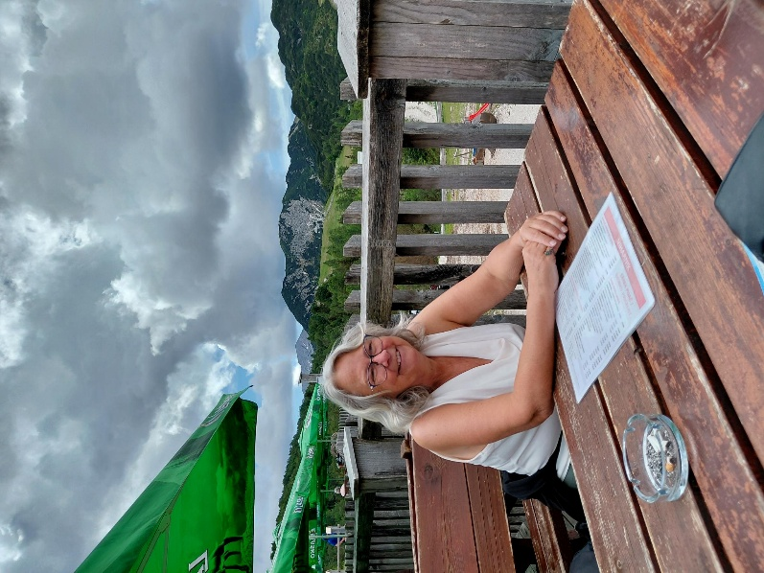
We ascended in a cable car which takes you to Brown Rock, 1000 metres above Lake Bohinj, at an altitude of 1535 metres. From there we enjoyed a view of the Bohinj Basin with Lake Bohinj.
Annette was terrified in the cable car, and I offered to stay with her at the bottom, but she said no, she had to do it. And she did. At the top we had blueberry schnapps to celebrate!
We had an hour at the top to admire the views and eat our packed lunches. (Annettes pizza from yesterday, and I had bought a wrap in the supermarket).
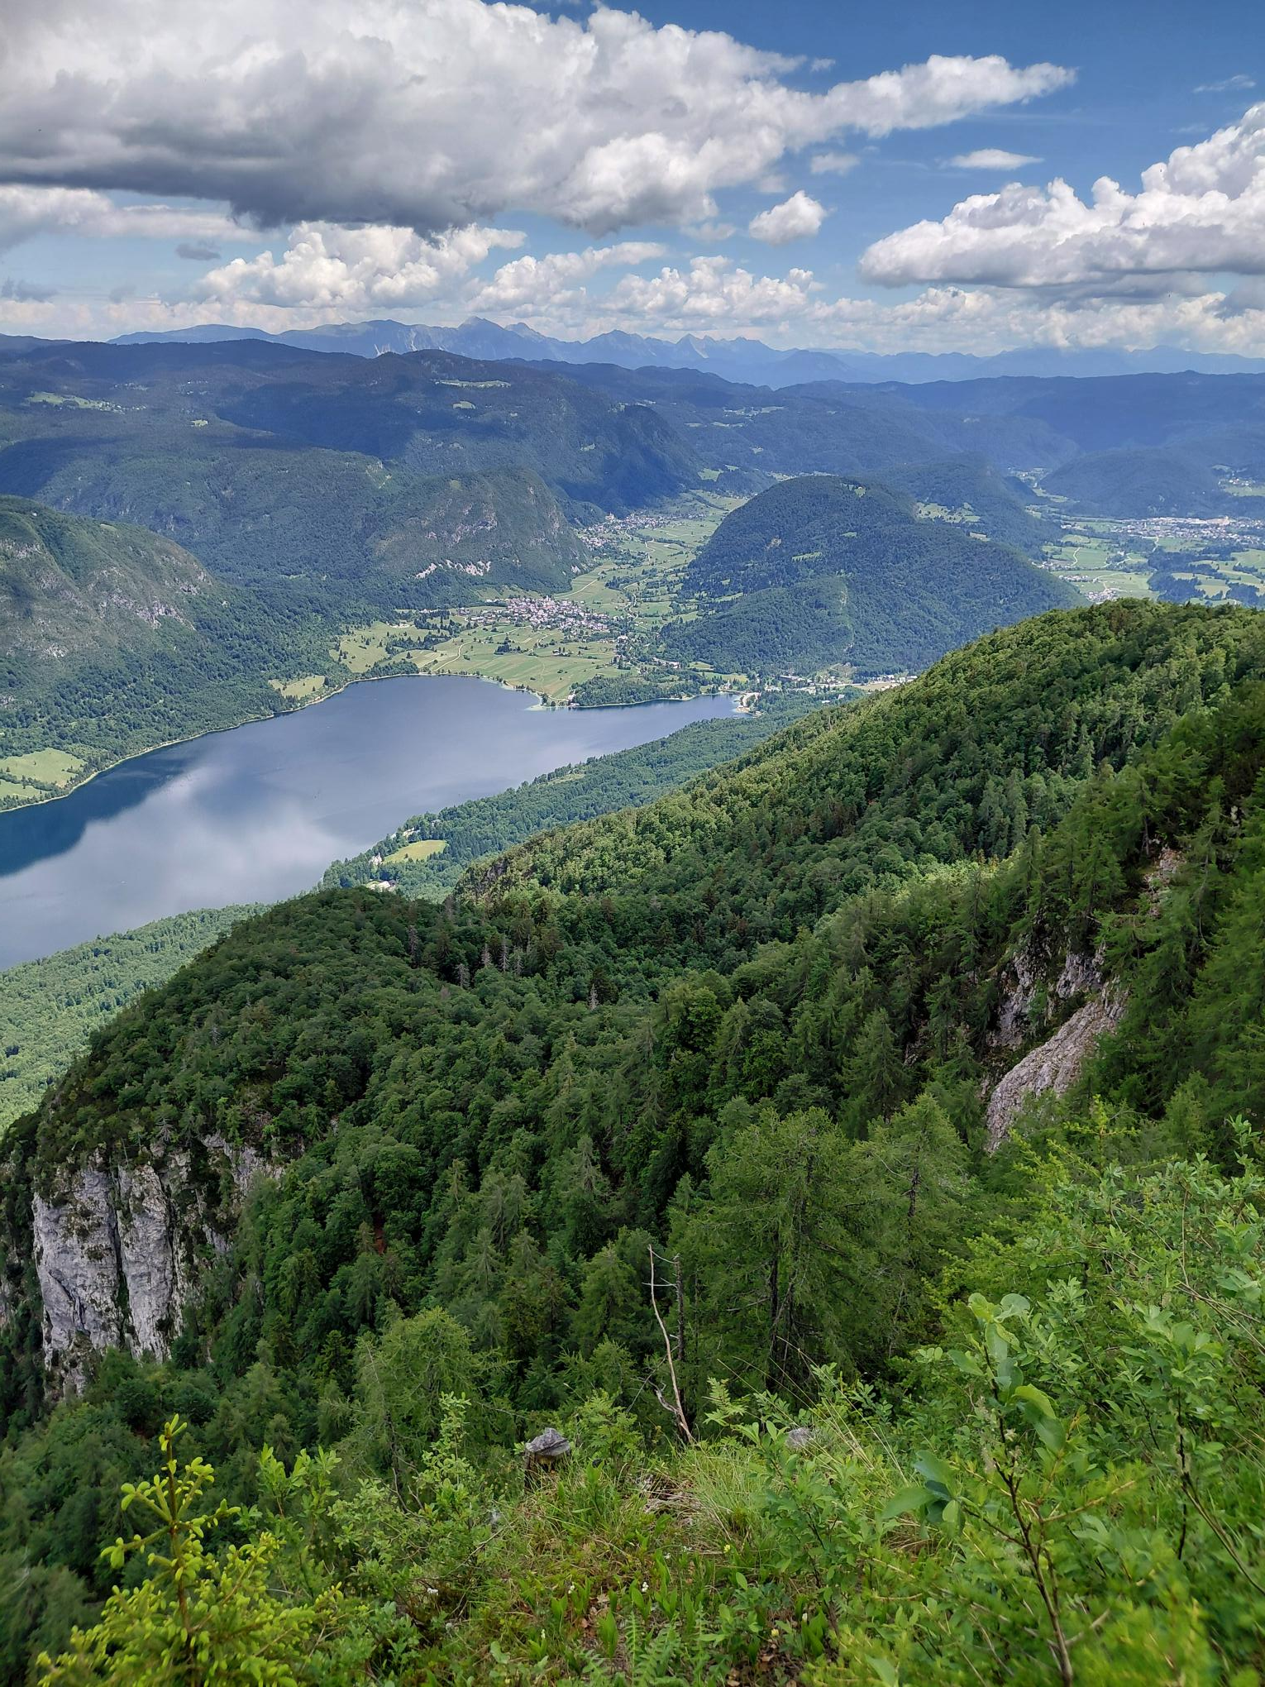

There were some wooden carvings at the top, which were beautiful.
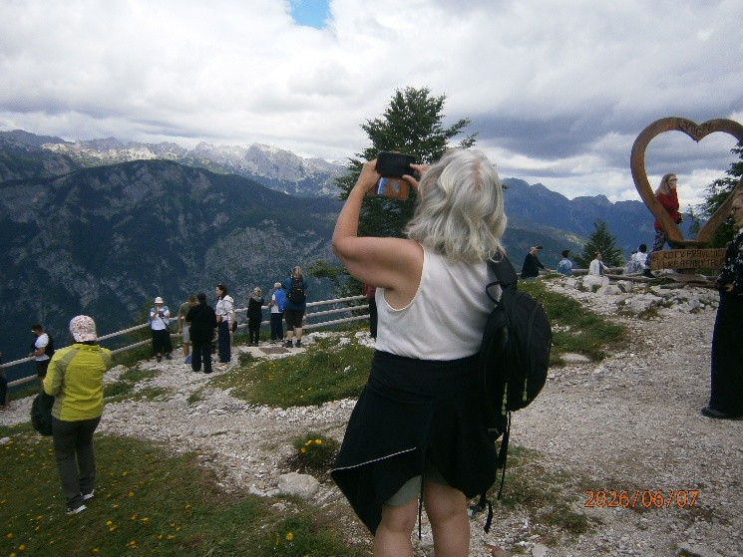
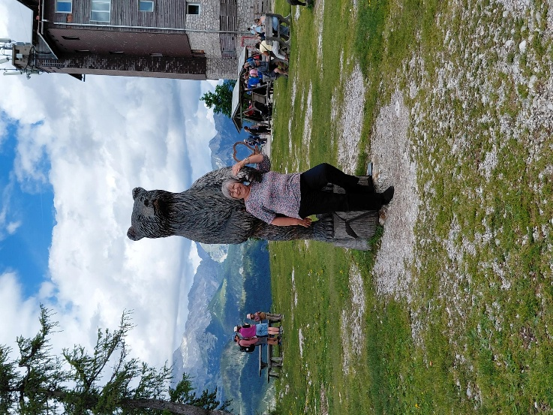
Some of the quicker members of our party went up further in the ski lift. We stayed put enjoying the views and the respite from the heat. It was 31degrees in the valley. Back on the coach we went to Bohinj for an ice cream stop.
Me, Adrian, Caroline & at Lake Bohinj
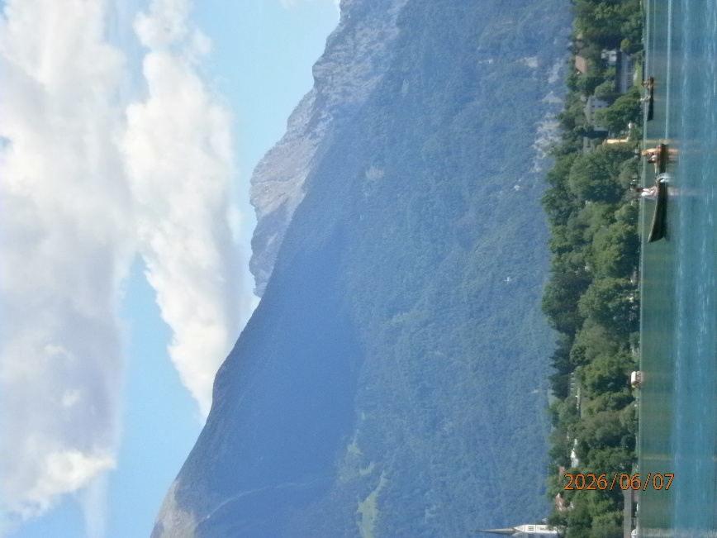
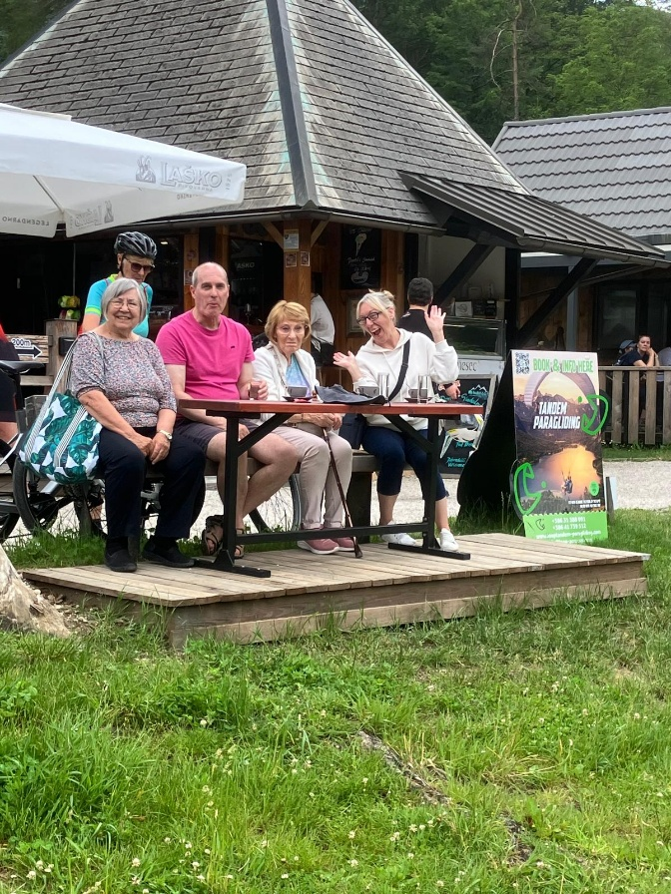
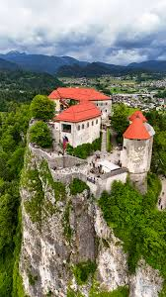
After our break we went on to Bled castle, which just happened to be holding its annual medieval festival. ~ how lucky were we! Bled Castle is a medieval castle built on a precipice above the city of Bled in Slovenia, overlooking Lake Bled. According to written sources, it is the oldest Slovenian castle. Built on a 130-meter-high cliff, Bled Castle once served as a strategic lookout point. Its spectacular view inspired France Prešeren, who described it as a “vision of paradise”. The Castle Printing Works at Bled Castle houses a replica of Gutenberg’s 15th-century printing press, which enabled the spread of knowledge across Europe. Annette treated me to a glass of white wine, which we had sitting on the terrace overlooking Lake Bled. A jousting tournament took place as well as some marching with drums. It was bustling. Down towards the entrance medieval swings had been set up as well as archery and of course souvenirs.
I spoke to Pete at Bled castle as he had dashed down to see Mum, who apparently was black and blue, but quite chirpy.
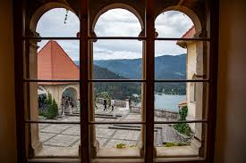

The terrace through a window (Internet Photo)
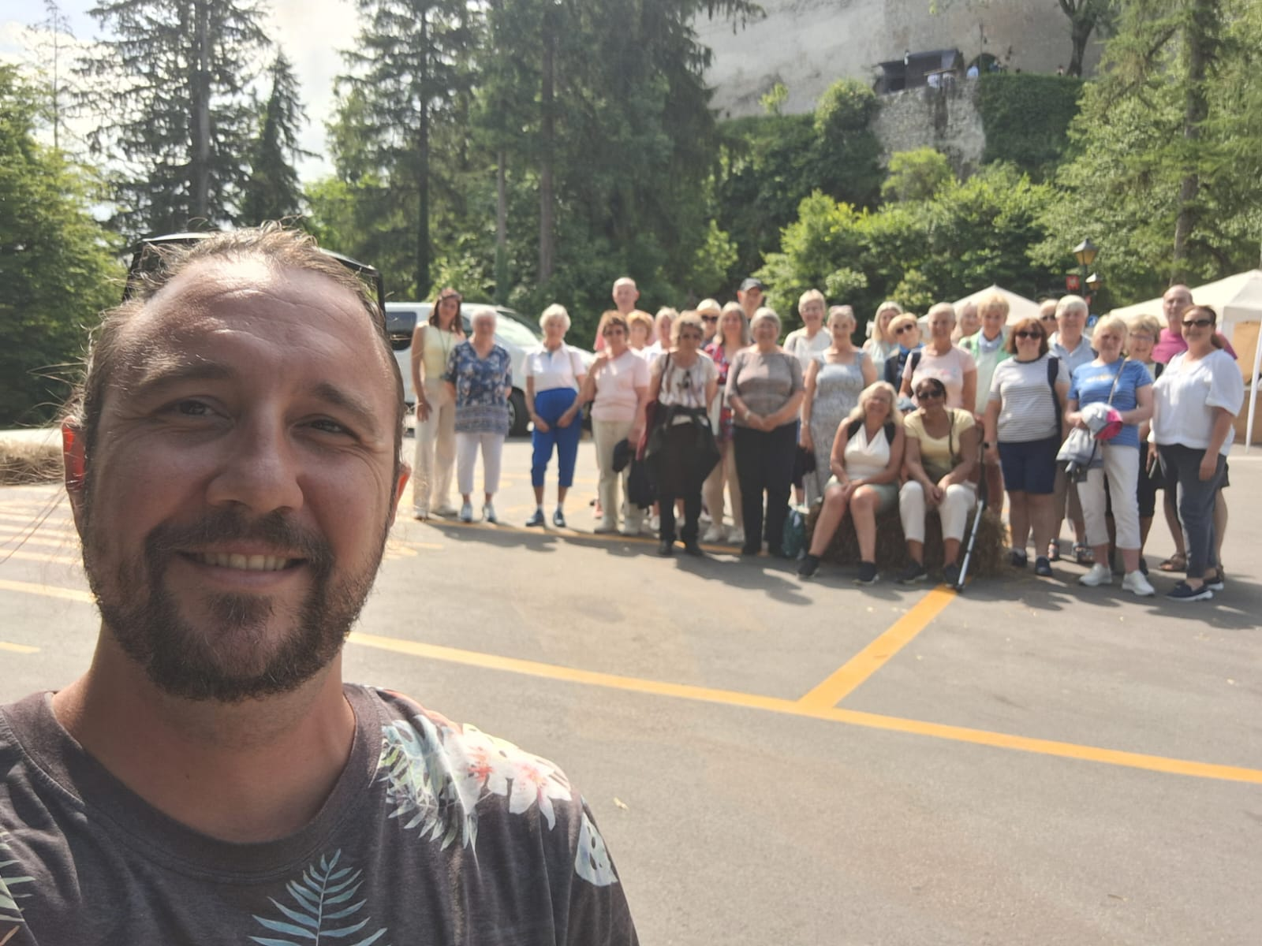
We had a group selfie with Matej in the carpark.
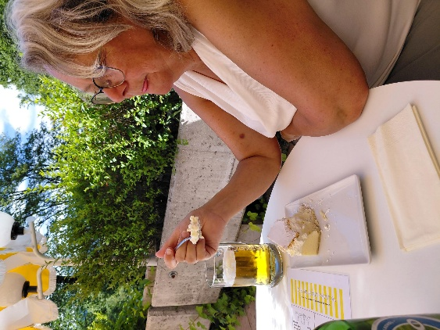
From Bled castle we went into the town of Bled for a wander, or in our case a beer and sit down on the terrace of the “old cellar restaurant” which was a boutique restaurant. It has been a very hot day, and we were all getting weary. The few walks we had done were steep with cobbles.
The beer was nice and cold. Annette tried the speciality of Bled cream cake (Blejska kremšnita). It features a golden, crispy puff pastry base layered with rich vanilla custard, sweetened whipped cream, and another sheet of puff pastry, all heavily dusted with powdered sugar. She said it was very nice but couldn’t finish it.
Day 7 Monday
We had an early start today. Our coach was departing at 08.30. Not everyone was going on this optional tour.
We first went to Postonja Caves, which were amazing.
Postojna Cave is a 24.34 km (15.12 mi) long karst cave system in southwestern Slovenia. It is the second-longest cave system in the country. The caves were created by the Pivka River. Graffiti inside dated back to 1213.
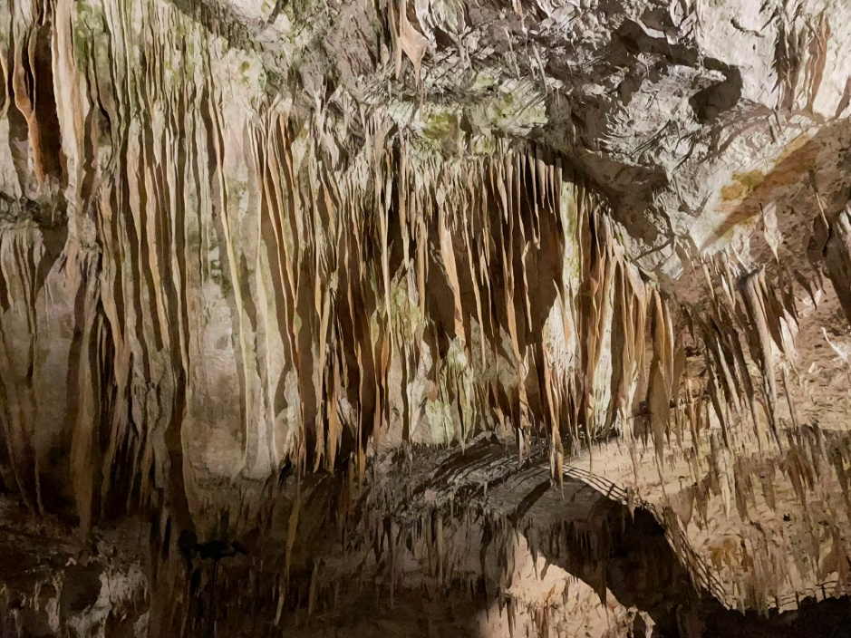
In 1818, when the cave was being prepared for a visit by Francis I, the first Emperor of Austrian Empire, a new area of the cave was discovered accidentally by Luka Čeč, a local man in charge of lighting lamps in the cave.
During World War I, Russian prisoners of war were forced to construct a bridge across a large chasm inside the cave. We walked over this and later under it. It was quite high up.
During World War II, German occupying forces used the cave to store nearly 1,000 barrels of aircraft fuel, which were destroyed in April 1944 by Slovene Partisans. The fire burned for seven days, destroying a large section of the cave and blackening the entrance.
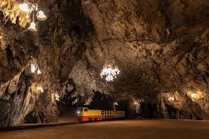
The cave also houses the world’s first and only underground post (Internet photo) office which initially opened in 1899. There is also a Concert Hall, complete with chandeliers and crystal wall lights. It is known for its exceptional acoustics, has sufficient space for 10,000 people. Symphony orchestras, and a variety of soloists perform here.
There are stalagmites, stalactites, and formations called curtains or draperies that look like folded curtains, and others that look like spaghetti.
One cave sparkled with natural crystals and was absolutely fabulous. Unfortunately, photos couldn’t capture it.
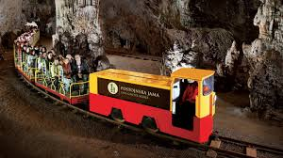
The caves are also home to over 150 species of primarily highly adapted cave-dwellers (troglobites) that exist nowhere else on Earth. The most famous is the Olm, a pale, blind aquatic salamander historically known as the "baby dragon" It was actually quite small; A blind, tiny-necked cave beetle; Tiny cave shrimp, worms, and water snails that make up the food chain for larger predators like the Olm, and specialized spiders, pseudoscorpions, and cave crickets that navigate the darkness using heightened senses.
The train ride in and out of the caves took about 20minutes and was like riding a ghost train. Jerky and in places dark until it triggered the sensors that lit the caves. It would have been worth the trip just for the train ride into the main caves. The whole tour took about 1.5hours

Emerging into the heat of the day, there was just enough time to catch a self-service chicken wrap and coffee, visit the loo and tat shop, before getting back on the coach to visit Predjama Castle.
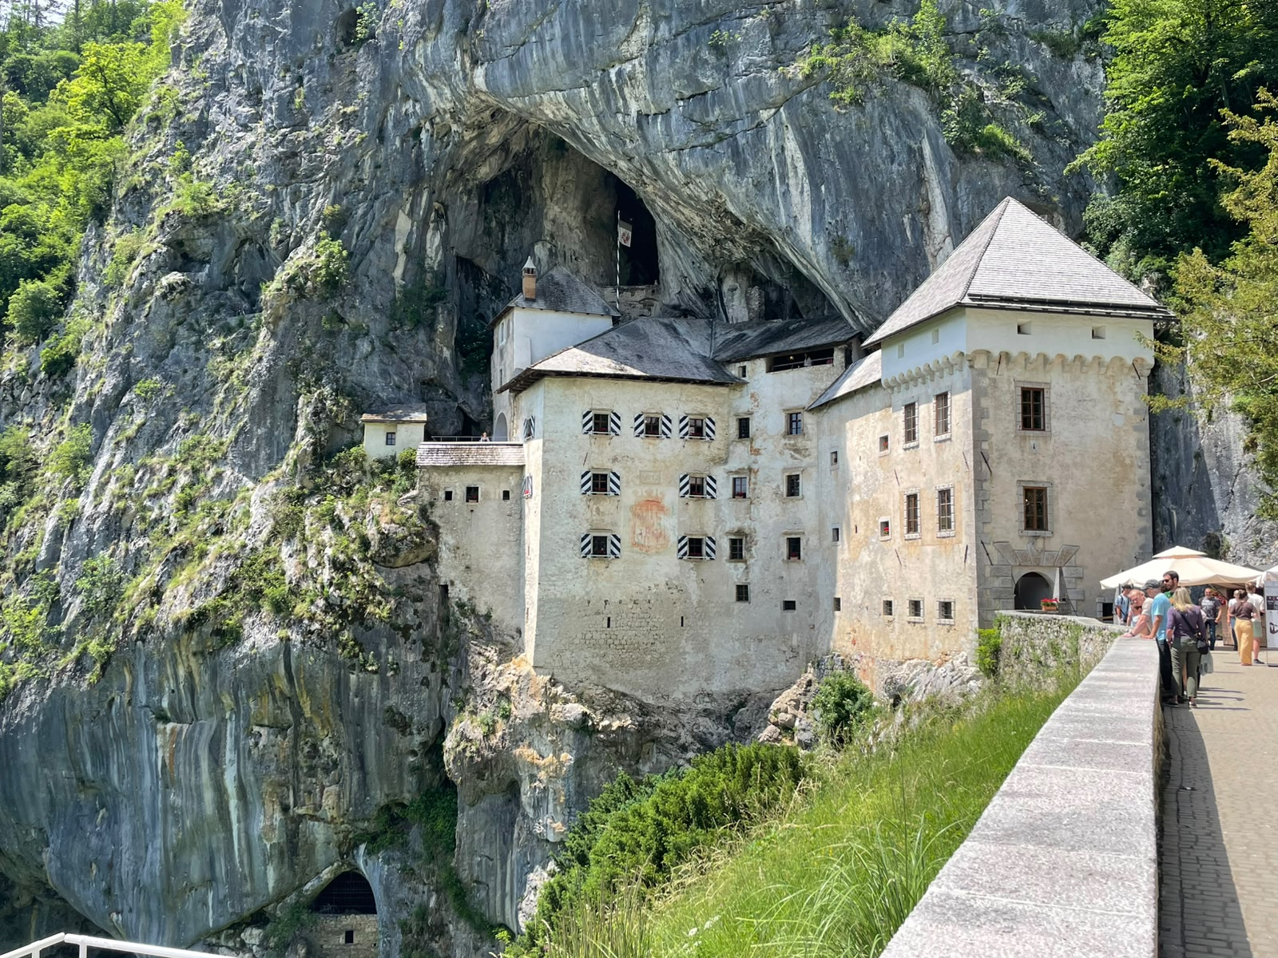
Predjama Castle was not at all what I was expecting to see. It was a Renaissance castle built into a cave, and virtually impregnable. Picturesque, magnificent, defiant, mysterious and impregnable, it has been dominating the surrounding area, perched high up in the 123-metre-high cliff, for more than 800 years. It is listed among the Guinness World Records as the largest cave castle in the world.

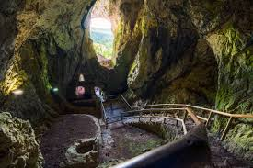
According to legend, Erasmus, lord of the castle, came into conflict with the Habsburgs when he killed the commander of the imperial army, who had offended the honour of Erasmus's deceased friend. Fleeing the vengeance of the Holy Roman Emperor Frederick III, Erasmus reached the family fortress of Predjama. From there, he allied himself with King Matthias Corvinus and began to attack Habsburg estates and towns in Carniola. The emperor commissioned the governor of Trieste with the capture or killing of Erasmus. Erasmus was killed after a long siege. According to a popular but unfounded legend, Erasmus was betrayed by one of his men and was killed by a shot from a cannon in his lavatory. (which was the only vulnerable building in the fortress). Photo of Interior of the cave carved into the rock of Predjama Castle overlooking the outside.

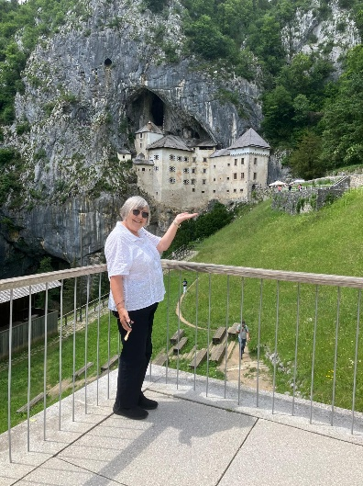
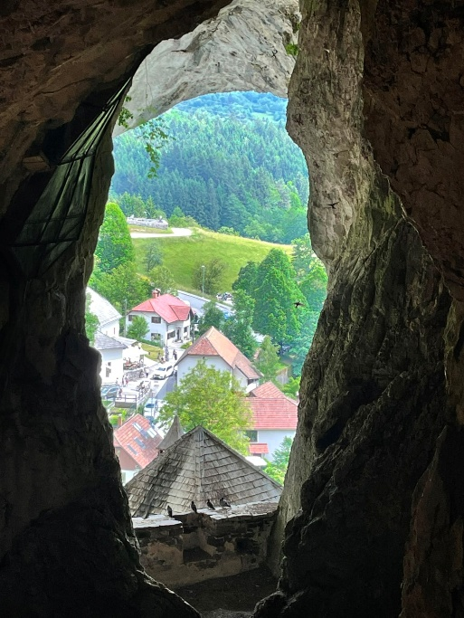
A vertical natural shaft, which Erasmus ordered to be enlarged, leads out of the original castle, and leads to an exit at the top of the cliff, 25 meters away from the cliff's edge. During the siege, this shaft allowed Erasmus to secretly supply the castle with food and to continue with his robberies.

We were back at the hotel by 5.30, with just time for a shower and change before going out to a restaurant for a farewell dinner and some dancing!
Dinner was lovely: Garlic or beef soup to start; followed by turkey, fish or pork, with salads and potatoes, and the classic Bled tart for dessert (which I couldn’t have) Mine was made a sacrifice (on a separate table) to the flies which were a nuisance.
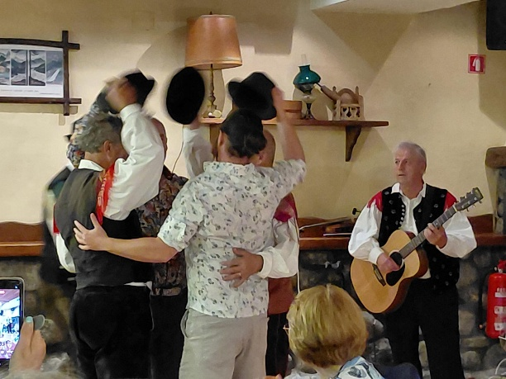
A local folk group came and sang and danced for us, but we were expected to join in.
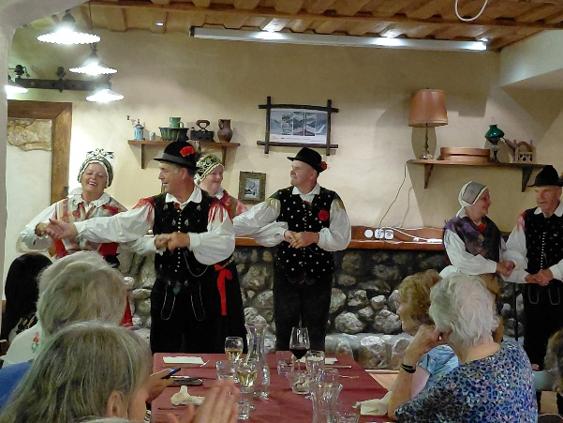

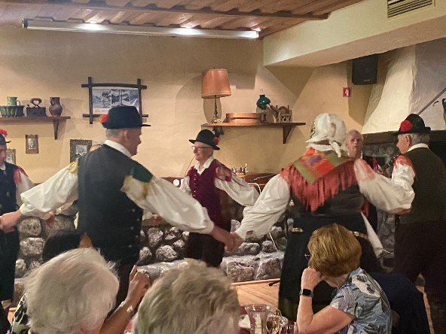
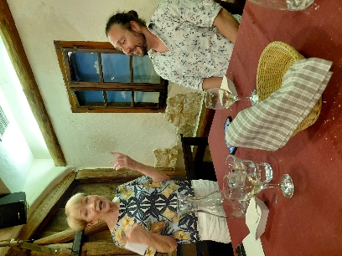
We had a collection for Matej which Irene presented to him.

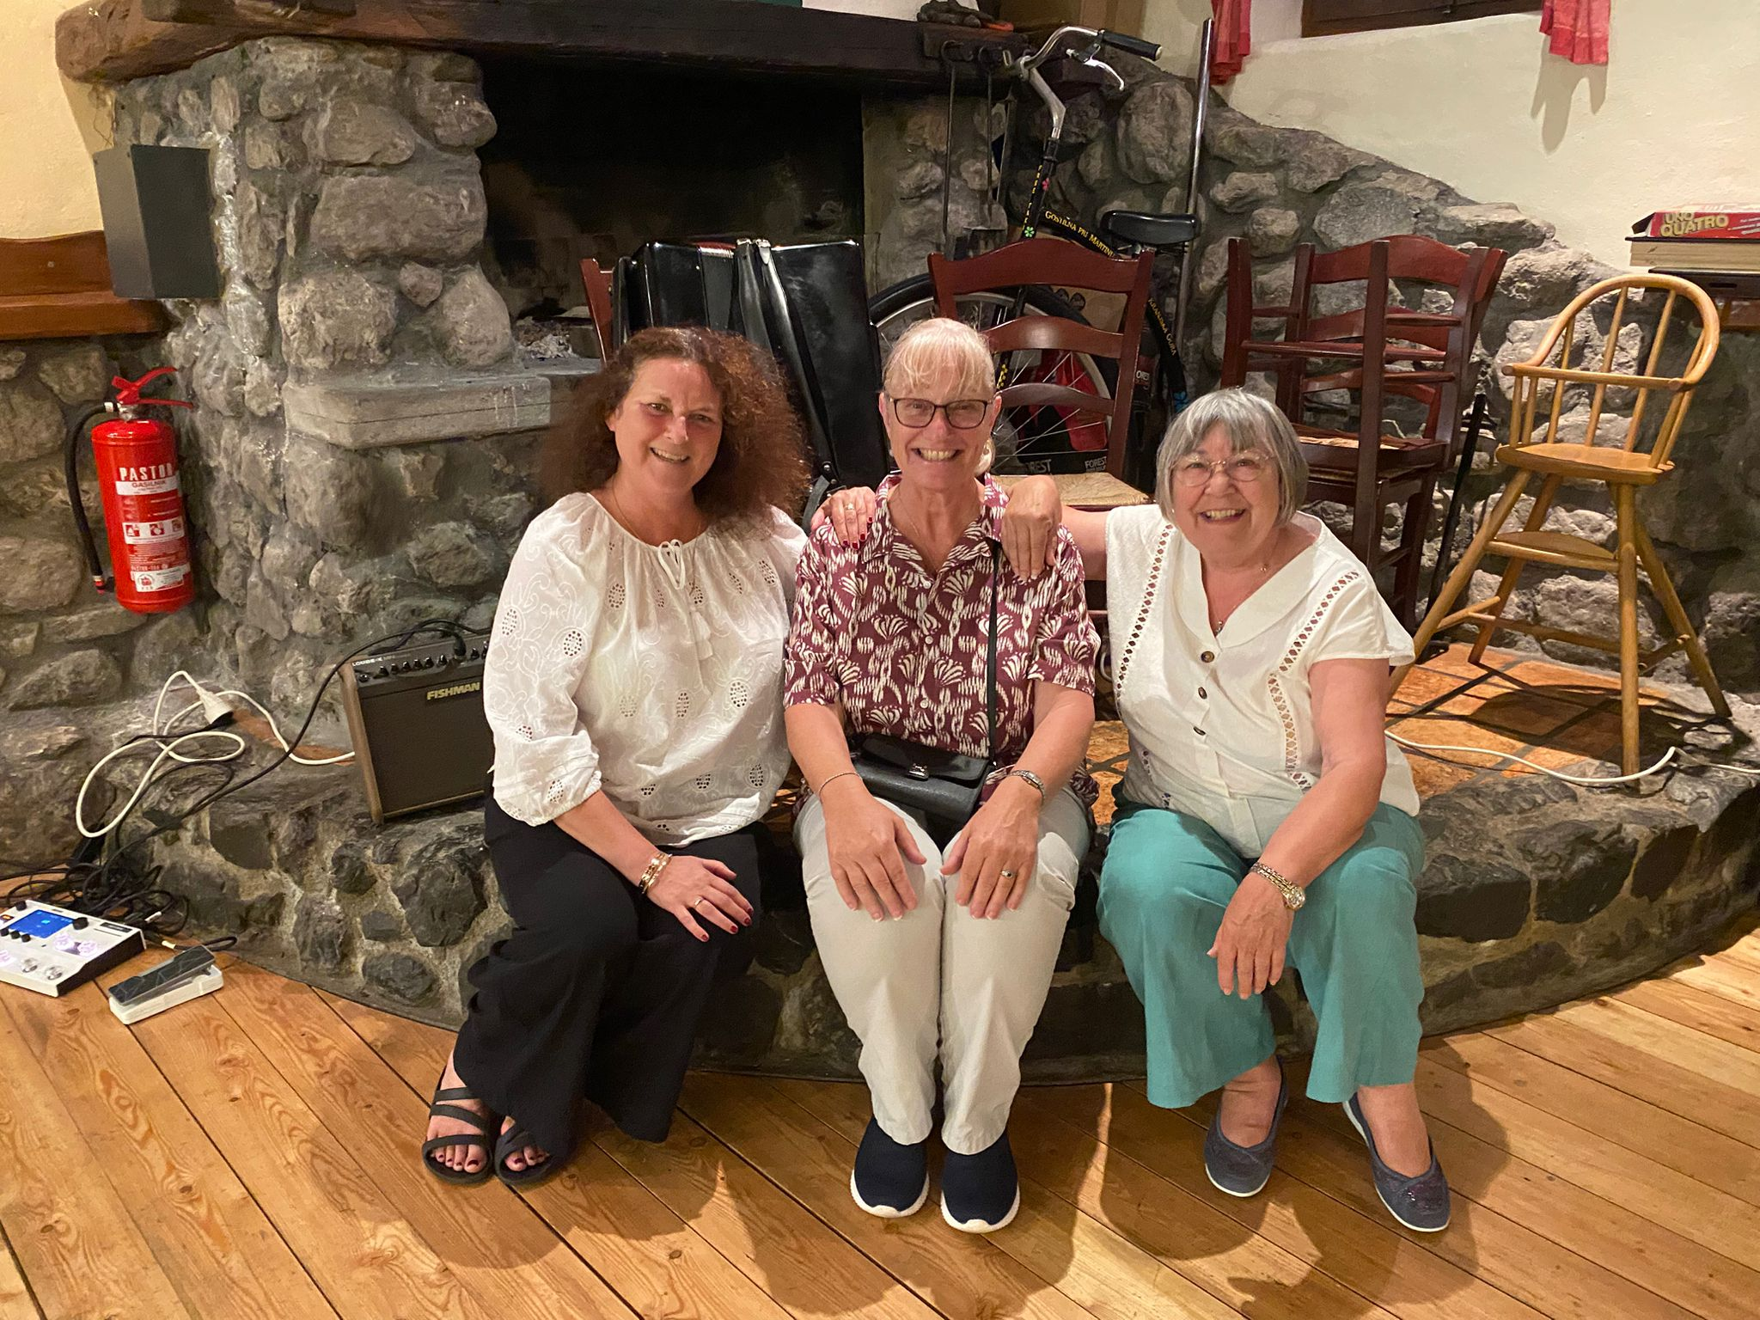I had my picture taken with Barbara and Wendy. Barbara (centre) has 2 sisters Wendy, and Lesley ~ so we were sisters for the night!
Wine was flowing freely, and as we left the restaurant (after the main bulk of our party), the proprietor gave us glasses of strawberry schnapps.
Back at the hotel, I took my documents out of the safe and put them in my carry-on bag. My case was nearly packed, and we don’t have to be out of our rooms until 11.00am.
It was once again a noisy night with army helicopters landing nearby at around midnight, and again at 5.30am. I was awake, showered and packed by 7.00am.
Everyone trickled into the dining room today. There weren’t so many cheerful faces either. We had all enjoyed our holiday and didn’t really want to go home.
After Breakfast, Annette and I wandered the few “tat” shops, visited the church, supermarket and the peace garden, before stopping off for a coffee to while away the time before returning to the hotel.
Most people were sat inside, but we sat outside on the newly built decking, soaking up the sun.
Eating out is difficult for me here, as they are fond of cheese with everything and cakes are creamy. I ended up buying 2 protein bars and a bottle of water to go with my 2 bananas. They would have to last me approximately 14hours for the journey home.
Security took my new bottle of water off me at the airport, as they don’t have the equipment to scan it – It hadn’t been opened either! So I had to buy another one in duty free.
The flight was uneventful, my bananas got squashed in the bottom of my bag (fortunately I had them in a plastic bag), so I only got to eat one of them, the other was beyond redemption! However, I had a complete row of sets to myself!
At Heathrow, I managed to buy a tuna sandwich, before catching an earlier coach. 10 minutes later and I would have missed it.
So I said farewell to Annette who was getting a coach to Gloucestershire and travelled back to Plymouth.
There was a tail back on the M4 due to an obstruction, and parts of the M5 were closed which caused us delays. From Exeter the coach went all around the coast: Torquay, Paignton, Totness, Newton Abbott and finally Plymouth. I was the only one left on the coach after Totness.
I had kept in touch with my taxi company to let them know I was delayed and he got there 2 minutes after me. I was glad to crawl into bed at 3am. Unfortunately had a busy day ahead, collecting the cats, a WI committee meeting and a Tesco delivery.

