Eastern Europe on The Danube
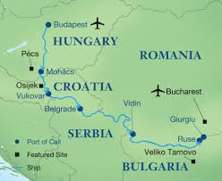

30/09/25
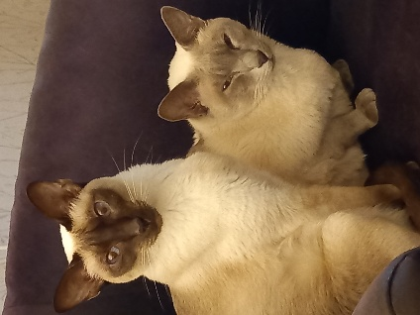
I had a restless night. Zubia didn’t come to bed like he always does. He snuggled down with Jemma. I had treated them with flea and worming solution, and they don’t like it.
After chasing them round the living room, I got them in their carry crates and took them to the cattery.
June came and picked me up from home at 2pm, and despite road works, dropped me at the coach station early. I sat reading for a while, and said hello to a surprised Christopher Lunn, (who lives in our village & was popping into town).
The coach left on time, and we had an uneventful journey to Heathrow, arriving at 8.15pm. It was then the long trek down in the lift to terminal 2, along the travelator, and back up in the lift to the hotel buses.
I got off at Ibis, only to find it was the wrong one. Three other people did the same, so we walked together to the other one. (10 minutes the receptionist said, it might have been by car). 45minutes later we got there. (I wouldn’t have walked it on my own).
My room was on the 5th floor. – One of the lifts wasn’t working, & there was a notice apologising for no water pressure for showers. I did squeeze enough water out of the tap for a coffee though. We were told the kitchen was closed, but the bar was open. – Thanks!
I set my alarm for 6.30; and because I couldn’t lock my room, wedged my hefty case across the door, with my hand luggage on top. – It will make a clatter if nothing else.
1/10/25 Wednesday
I slept reasonably well but was awake by 5.15am. I put the TV on to keep me awake while I made a coffee and dressed.
After getting the Hoppa bus to the airport, & finding out where I had to go, I checked in my luggage via a machine (no staff nowadays). Went through security, and minimal passport control, bought a sandwich for the flight and a bacon roll for breakfast, and then found out my flight was delayed!
At 9.45 we were called to our departure gate and taken by cattle truck to our Airbus A320. My seat was the middle one of 3, between 2 friends who were talking through me. Then I had a stroke of luck; someone moved seats, and I moved to their aisle seat (which I much prefer) and we finally took off at 10.45 for our 3hour flight. We were taken by bus to the airport arrivals as our pilot said we were so far out, we were off his charts of the airport! They appeared to be resurfacing or building a new runway.
Arriving at Bucharest, Romania, on time, we joined a dense queue for passport control, then a long trek to baggage reclaims, via escalators that weren’t working!
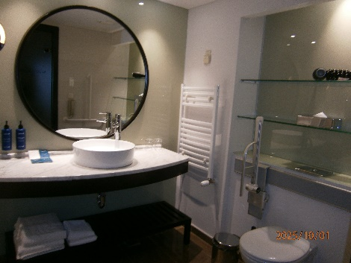
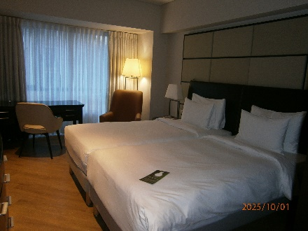
As usual, my case was one of the last to arrive, and I soon met up with the Emerald Waterways representative and joined a group waiting to be taken to the Raddison Bleu Hotel. Our cases were dealt with by bell boys. My hotel room was nice. It was on the first floor, right over the entrance canopy.
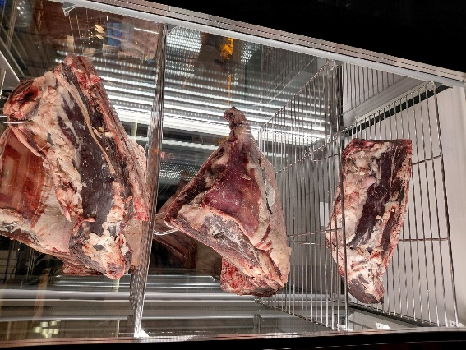
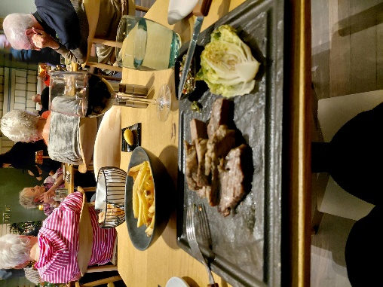
We were to meet a guide in the breakfast room for a welcome talk and half glass of wine. After that, I made my way into a steak and fish restaurant in the hotel for dinner. I chose Brisket with fries, accompanied by a glass of wine. The steak just melted! The fries were hot and crispy too. The bread was black, very light, very similar to sourdough. It was very tasty and soaked up the wine very nicely.
The restaurant was decorated with driftwood and grasses hanging from the ceiling, with geometric lighting and mirrors. It filled up quickly. I think I’m the only solo traveller, so no awkward chats, done when I’m finished, and bed when I’m tired.
Peter caught my eye with a question; and I replied with a thumbs up! (I had met Peter and his wife Elaine at the talk)
The one-upmanship has already started; - an American couple told the people next to them; they have been on over 100 cruises. I’ve done 2 ocean ones and 3 river cruises. – I wonder what they learnt along the way about the places they have visited.
My case had to be outside my room by 7.00am, so after getting washed and dressed, I went down for breakfast. There was everything you could imagine: cooked breakfast, cereal, fruit, smoothies, bread, cakes, rolls, cheese and cold meats. I chose cornflakes with fresh fruit, followed by bacon, sausage, mini roast potatoes, and mushrooms. – Sadly, it was all tepid. The bread was nice and fresh though.
I returned to my room to get my jacket before getting on board a sightseeing coach.
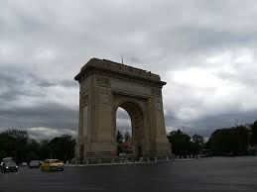
Known for its wide, tree-lined boulevards, glorious buildings and a reputation for the high life (which in the early 1900s earned its nickname of "Little Paris"), Bucharest, Romania's largest city and capital, is a bustling metropolis. Legend has it that the city of Bucharest was founded by a shepherd named Bucur, whose name literarily means "joy." His flute playing reportedly dazzled the people and his hearty wine from nearby vineyards endeared him to the local traders, who gave his name to the place.
We circled the 1930s Arcul de Triumf (Arch of Triumph), the symbol of both Romania's victory in the First World War and its unity (a replica of the Paris original).
Stained beauty threads its way through this leafy city. Orthodox churches rub shoulders with monolithic communist drudge, French-inspired mansions and apartments and art deco survivors of dictator Nicolae Ceausescu's deeply disturbing rule. And there's still room for Bucharest's delightfully wide boulevards, lush urban parks, an Armenian cathedral and University square, along with his parliament palace of 1,000 rooms and over 2,000 chandeliers. The city breathes history, from Saxons to Ottomans; the 2 world wars, Soviet occupancy and communist rule, before becoming free.
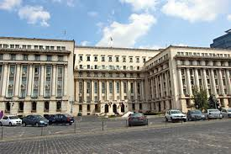
One of Bucharest's areas most often associated with the Internet photo 1989 unrest that lead to the demise of Romania's Communist Regime is Piata Revolutiei. Revolution Square gained international notoriety when TV stations around the globe broadcasted Romania's Communist leader Nicolae Ceausescu's final moments in power, on December 21, 1989. From the balcony of the former Communist Party Headquarters, Nicolae Ceausescu stared in disbelief as the people gathered in the square and turned on him. He fled the angry crowd in his helicopter and his 34-years in power ended. He was abandoned on a quiet road, captured and executed. Romania has a habit of executing their leaders.
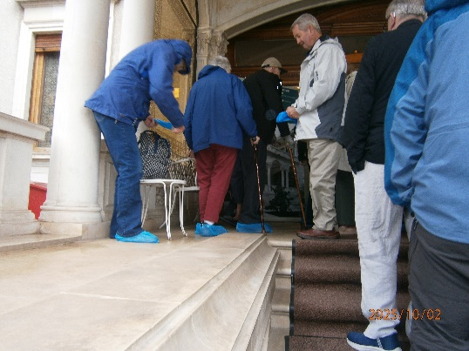
Our destination was “the Spring Palace” which was built between 1964 and 1965 and served as the private residence of Nicolae and Elena Ceausescu and their children - Nicu, Zoia and Valentin - for a quarter of a century until the outbreak of the '89 Revolution. They all had their own apartments here. Many official meetings and crucial political decisions for Romania also took place here. The Spring Palace was not only a residence but also a symbol of absolute power and the cult of personality cultivated by Ceausescu.
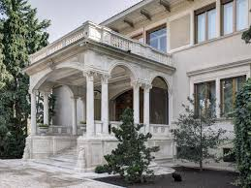
We had to stop and put plastic over shoes on to protect the carpets and flooring.
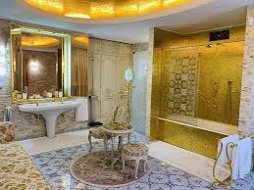
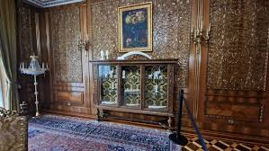
Architecturally, the Spring Palace is an outstanding example of opulence and luxury, reflecting the extravagant style of the 60s and 70s. Its interior is decorated with marble, precious woods, elaborate mosaics and impressive chandeliers, every detail
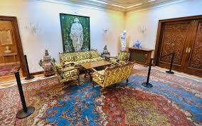
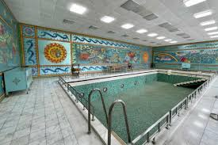
designed to demonstrate the power and wealth of the Ceausescu regime. The rooms are furnished with luxurious furnishings and many of them retain their original decorations. The gardens, golden bathroom and indoor pool complete the sumptuous residence. It was hot and airless. We weren’t allowed to touch anything or take photos. Not my thing. I like visiting palaces, but this one left me cold.
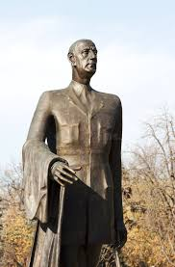
Charles de Gaulle Square is a significant landmark featuring a statue of Charles de Gaulle, a monument known as the Millennium Cross, and access to Herăstrău Park. The square has also been known by other names throughout history, including Stalin Square, and originally Hitler Square.
Eastern European history is a complex mix of empires, diverse people, and political shifts, marked by its position as a buffer zone between major powers. Key periods include the medieval influence of Byzantium era, the struggle against the Ottoman Empire, the rise of autocracy in Russia, the emergence of strong nationalism in the 19th century, and the devastation and Soviet domination during the 20th century. The collapse of communism in 1989 ended the Soviet bloc, leading to a new era of independent states and reintegration into Europe.
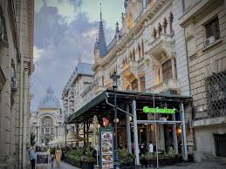
We were deposited in the centre of old Bucharest for a lunch break. Most people went into Caru’ cu Bere. With a history of more than 130years Caru’ cu Bere is a symbol of Bucharest’s old town and is the favourite meeting spot for locals and tourists alike. Among them were the Rolling Stones, Naruhito, the Prince of Japan and Edward Kennedy. Internet photos
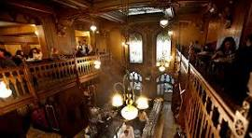

The vaulted ground floor is richly decorated with paints, stained glass and mosaics.
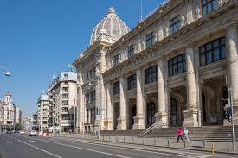
I didn’t go there. I found a small café which roasted its own coffee. I didn’t want a big lunch as we would have dinner on board ship, so I had a piece of local cake. There were couple of souvenir shops, but the rest of the buildings were mainly restaurants. Needing to use a loo, I made my way to the National History Museum opposite where we were to get our coach. – It was closed!
Internet photo
A number4 Emerald coach pulled up & I got excited, but it was a coach coming from the ship, with a group doing our trip in reverse. It was here I got to know Christine and Brenda, who were also cold, wet and in need of a loo. Our coach turned up at 2pm exactly, and we were all aboard within 5 minutes, glad to get out of the rain and warm up a bit.
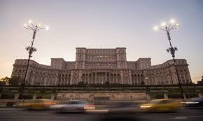
We had a photo stop at the Palace of the Parliament, or Palatul Parlamentului.As it was raining hard, I declined, and my picture is from the internet. It is the seat of the Parliament of Romania and is the heaviest building in the world, the world's second-largest administrative building, and the third-largest administrative building by volume. Known for its controversial construction under dictator Nicolae Ceausescu, it also houses several museums, a conference center, and is a major tourist attraction. Donald Trump wanted to buy it and turn it into a casino. Michael Jackson gave a speech here and instead of saying hello Bucharest, said hello Budapest!
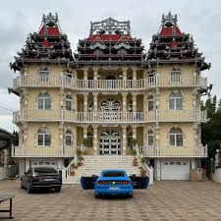
Driving to the port of Giurgiu to join our ship we passed quite a few Gypsy palaces. "Gypsy palaces" in Romania are elaborate, ostentatious mansions built by wealthy members of the Romani community, often in rural areas or on the outskirts of towns. These structures are symbolic status symbols that reflect their owners' newly acquired wealth, despite their often-unfinished state and grand, flamboyant architecture. Many are not lived in, and the families may reside in more modest dwellings on the Internet photo property.
We were then driving through the Danube flatlands, where wheat, corn and sunflowers are grown. Half of the income of Romanians goes on various taxes. Income tax is a flat 10% for everyone.
The city of Giurgiu has huge potential because of the Danube. The Giurgiu-Ruse Friendship Bridge, in the shared Bulgarian Romanian section of the Danube, crosses the river, which was built with the assistance of Russia. It is a very dismal looking area. With ruins of a fortress from the 14th Century; derelict factories; disused railways and farm machinery, and abandoned vehicles.
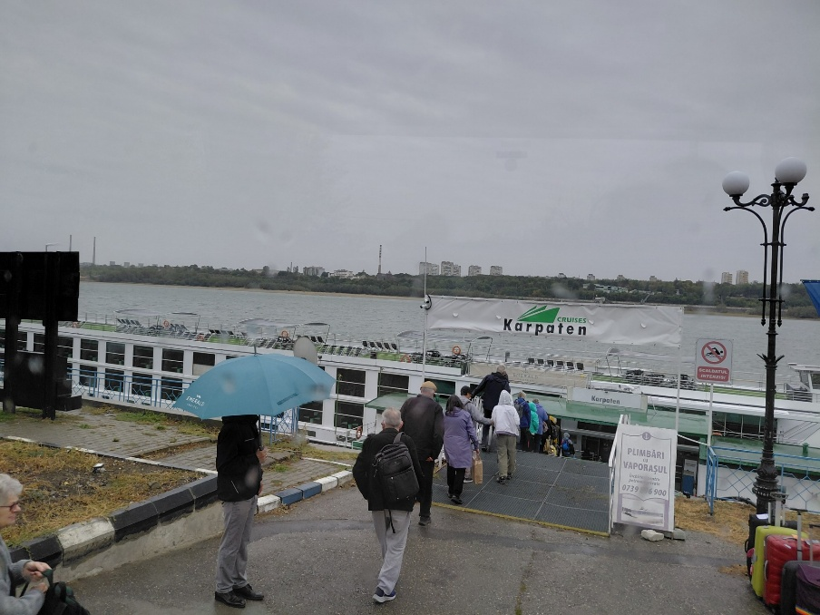
Our first sighting of our ship.
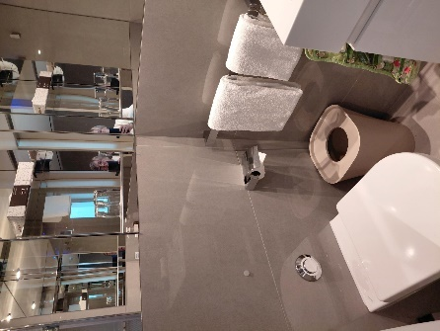
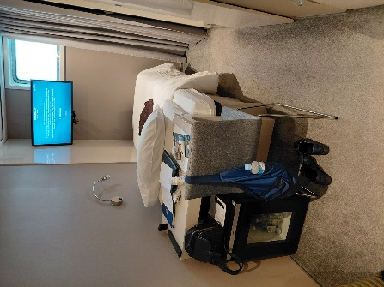
We boarded our ship at 4.00pm and by 5pm we had crossed the river to the port of Ruse, in Bulgaria. Our first cruise stop; all of 100yards!
My cabin was bijou. However, being on the lower deck, had wonderful water pressure for a welcome shower, after which I felt much warmer.
It was time then to hand in my excursion preferences; meet the chef to discuss my dietary needs and assemble in the lounge for a welcome by our captain Milan & our cruise director, Florin. Mainly health and safety stuff.
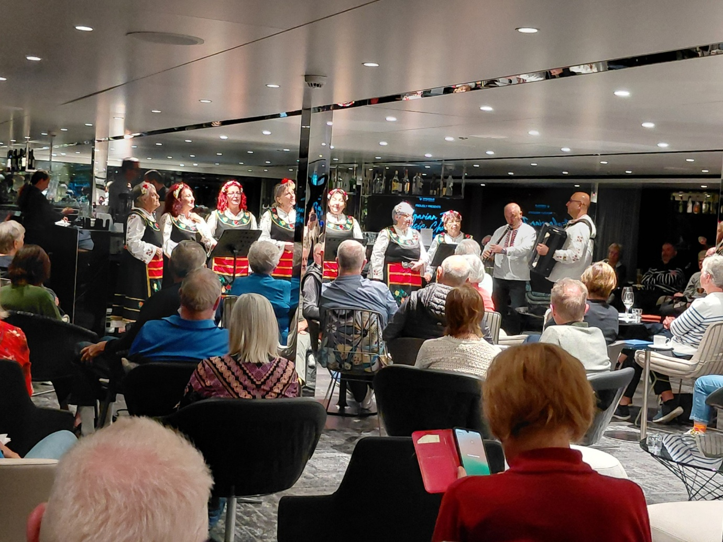
Dinner was a nice meal in the company of Peter & Elaine. (Romanian meatball soup; fish fillet & Plum mousse washed down with Merlot) After our meal we were joined by Pat and Jim from Canada, while we were entertained by a choir with local folk songs. It would have been nice to understand what they were singing about. They were accompanied by a flutist (who also played the bagpipes) and an accordionist. There was also a young man with a piercing whistle who danced with his hands on his hips. Their costumes were beautiful, mainly black with red and yellow embroidery; the men’s shirts were embroidered round the neck and down the sleeves.
03/10/25 Friday
Today, I have signed up for an active tour, to Basarbovo Monastery & Ivanovo Church.
It was very wet and windy. The river is grey and choppy, but it seems our hike is going ahead. So, after a huge breakfast of cereal, omelette, bacon and toasted fruit bread, I got dressed in my waterproofs and braved the elements to our coach. The wind was very strong and took my breath away.
Ruse gradually rose to prominence as a port for the river steamships that carried out the trade with Europe along the Danube. Another boon followed in the 1860s when the first railway line in what would be later Bulgaria was built between Ruse and the seaport city of Varna. The railway allowed goods from Central Europe to be moved quickly across the strip of land between the river and the sea and loaded onto sea ships bound to Istanbul and the rest of Asia Minor, avoiding a lengthy detour north through the Danube Delta. Ruse was also important militarily. Since the 18th century, it had been a part of the "quadrilateral of fortresses" Ruse—Silistra—Varna—Shumen, a quartet of fortified cities that guarded the corner of the Ottoman Empire in Europe that was closest to the Russian Empire.
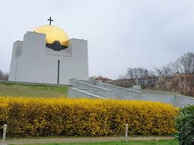
On our way we passed the Pantheon of National Revival which is a crypt in the Park of National Revival and is a vast square building with a gold-plated dome.
The Pantheon was built in 1987 to honour the centennial of the Bulgarian Liberation from the dominance of the Ottoman Empire. The monument was constructed over the old city graveyard. It keeps the remains of prominent Bulgarian revolutionaries who sacrificed their lives in the war for freedom.
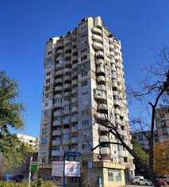
Under communist rule, the Bulgarian Orthodox Church was often suppressed, with religious life restricted and many churches demolished throughout the communist era. This coincided with poor air quality from the factories along the Danube. Many residents left Ruse. Once Communism was overthrown, the Bulgarians started to rebuild their churches and the air quality improved. – A miracle or coincidence? – After communism, many of the polluting factories were demolished and moved further away from the town. Hence the improvement, and Bulgarians are starting to return to the area.
The communists ruled that everyone had to be “equal”; although some were more equal than others. No-one was allowed to own property. All homes and land were confiscated. Everyone earned the same amount. There was no unemployment benefit. If you were disabled, the communists created a task specially for you, so that you weren’t a burden. The revolution came in 1989, & Bulgaria became a democratic republic. Land was returned to its owners where possible, and now everyone owns their own home (usually a flat) no matter how run down; and a lot did look shabby.
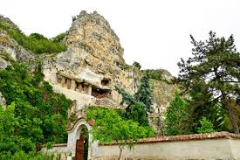
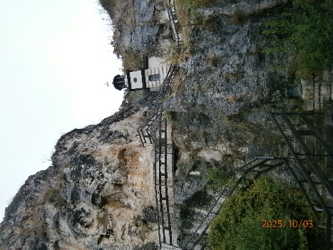
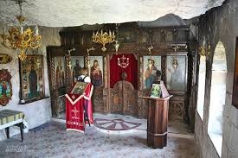
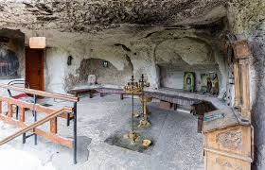
We were soon at the Monastery. Situated in the rocks of the picturesque valley of the river Rusenski Lom, the Basarbovo Monastery is the only active monastery in Bulgaria. It’s a place that is rich in history, nature, and mysticism. A place that brings out the spirituality in you and brings you a feeling of peace. Although it was established at the time of the Second Bulgarian Empire in the 12th century, the monastery only became famous in the 17th century, after the death of Saint Dimitar Basarbovski who was a monk living a quiet and peaceful life in the rocks of the monastery. The Basarbovo Monastery consists of residential buildings, a rock church and premises, and a bell tower. A well-kept and beautifully landscaped yard surrounds the buildings at the foot of a sheer rock face. The buildings are new, built in Revival style. The path, which leads people to the monastery, passes through an archway gate to reach the beautiful green inner yard and ends at a well that was dug by the monk Dimitar himself. Locals believe that water from the well has healing properties. To reach the rock church and the monastery’s shelters, you must climb 48 steep uneven steps, but once you reach the caves, the view makes you forget about the tiredness. First you can get to a platform with a niche, where the most famous monk of the monastery slept – Dimitar from the nearby village of Basarbovo. Totally carved into the rock, the rock church has a rectangular plan and measures 4.5 x 8.6 m. The eastern portion of this church has a semicircular apse. There is an entrance to the temple from the west. Its southern wall was built of stone during the restoration of the monastery in the 1930s.
Climbing more stone steps you can reach a cave-tomb where another famous monk, Father Hrisant was buried. He was the one who revived the battered monastery in the 1930s. It is located on the level of the rock church. In the past, the bones of the deceased monks of the monastery were placed in the room next to it but some years ago they were buried in the monastery cemetery.
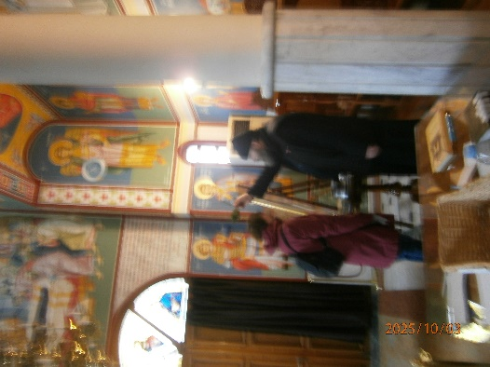
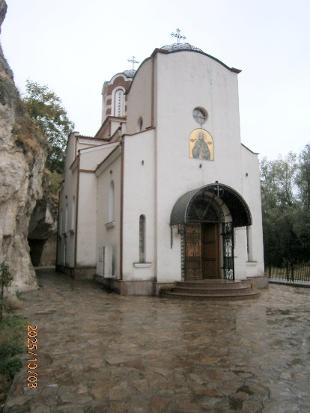
There has since been a new monastery building and living quarters for the monks. Where we each received a personal blessing after telling the monk our name. Water was sprinkled on our heads from a bunch of herbs dipped in holy water.
Back on the coach we made our way to the rock hewn churches of Ivanovo. They are included in the UNESCO World Heritage List.
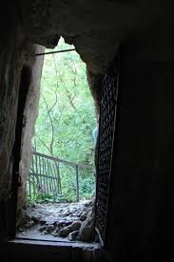
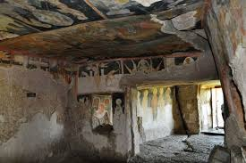
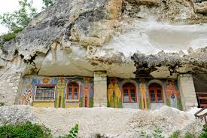
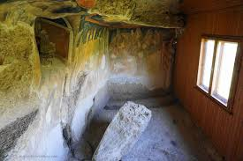
They are a complex of rock-hewn churches, chapels, monasteries and cells situated in the beautiful valley of the Rusenski Lom River, in North-Eastern Bulgaria, reached by over 100 steep and uneven steps, which were slippery from recent rains and fallen leaves. Hermits cut the first cells and churches into the natural rock along the riverbed during the 12th century. The entire complex was built between the time of the Second Bulgarian State (1185-1396) and the conquest of Bulgaria by the Ottoman Empire (late 14th century). At that time, the number of churches was about 40, while the total number of sites reached around 300, most of which are not preserved today.
The monastery complex owes much of its fame to frescoes that were created in the 13th- and 14th-century and which have been preserved in six of the temples as a part of the complex.
The rock monastery “St. Archangel Michael” is situated at the same site. It was founded in the 1220s by the monk Yoakim, who later became a Bulgarian patriarch. During the Second Bulgarian Empire the monastery established itself as a great spiritual and educational centre. Wall inscriptions in the cells provide information about important historical events.
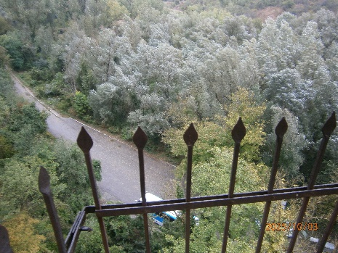
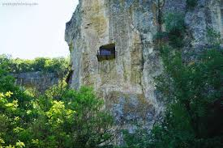
The frescoes in the church of “St. Mary” are world famous. They are among the most representative models of Paleologus Art on the Balkan Peninsula. Their exceptional artistic quality is why they have been included in the Unesco list of global cultural inheritance. They show the image of The Last Supper, painted 150 years before the one by Leonardo Da Vinci. The viewpoint from the main chapel is amazing. I’m glad I made the effort to climb the 206ft to see them. The climb certainly cleared out the lungs.
Back on the ship, we sailed within minutes, and watched Ruse disappear as we ate lunch. Bulgaria is now part of the EU, and roads have been built with EU money, as have EV recharging stations, but no one can afford to buy an EV car; they cost about 70,000 dollars. There was no referendum when Bulgaria joined the EU. It was decided by about 20 people!
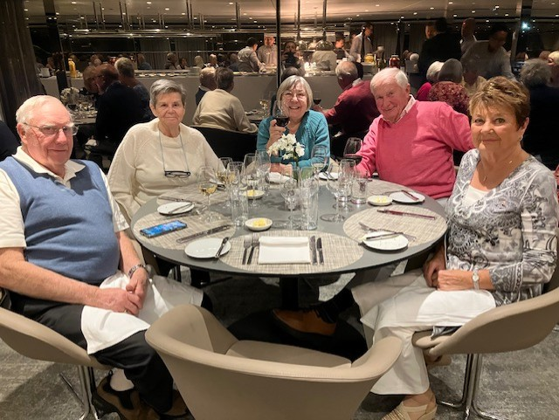
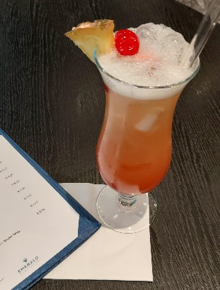
After lunch, I went up to the lounge to put my feet up and read with a Mai Tai cocktail until it was time for a presentation on the cruise and what we had to look forward to. It was during this time I was approached by a lady called Polly. She was in the cabin opposite mine. She said she knocked the previous day, but I wasn’t there. I’m glad,- because all she did was moan; - the cabin was too small, the window not big enough, the coach left without her, it was too cold etc. etc!
After the talk, I escaped Polly, and took a coffee back to my cabin, where I fell asleep, and woke just in time for our welcome dinner. Which was delicious and lasted nearly 3 hours and 6 courses. I sat with Peter, Elaine, Pat and Jim. They were good company, and we discussed sport, politics, history, TV, everything except religion. They were good company.

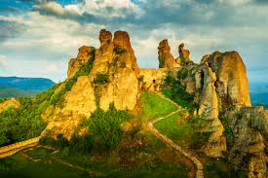
4/10/25 Saturday
We sailed all night towards Vidin in Bulgaria. I have a tour booked for Belogradchik Rock formations and fortress, (another “active” tour). Going up the steep gangplank, I twisted my knee, so rather than hold everyone up, because there were 300 steps, I swapped to a tour of a winery instead which had only 20 steps. The group going up to the Rock formations had snow. It was quite deep too. One man slipped and dislocated his shoulder.
The Balkan area had an unseasonably cold spell due to a storm elsewhere. Anyway, back to my tour.
The town of Vidin was settled in the third century B.C. According to unconfirmed reports the first inhabitants of the ancient town were from the Thracian tribe - Tribali. In the time under Ottoman rule the town was given the name Vidin. While it is not a thriving city, you can use your imagination to see the surviving baroque buildings and stone temples as they were in the town's heyday before it was greatly altered by communist rule. Bulgaria has many economic problems.
A lot of their “brandy” called Rakia, is home made from figs and quince and is 55% proof. During the covid epidemic they said a glass of brandy was a good disinfectant, and very few people got covid. It is harsh like schnapps.
The Bulgarians only use sunflower oil in their cooking as it is cheaper. It is grown and processed in Bulgaria. They also grow a special kind of rose to make rose oil, which is used in French perfumes. It costs 10-30 euros for a tiny bottle.
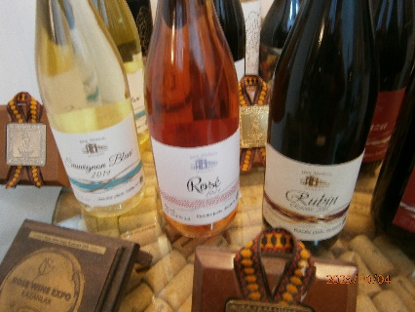
At the winery we were given 4 full glasses of award-winning wine. Surprisingly I preferred their Sauvignon Blanc and Rose to the reds, although the 4th red was OK, that came straight from the barrel. All of these were served with fresh bread to cleanse the palate, and local cheeses to complement the wines.
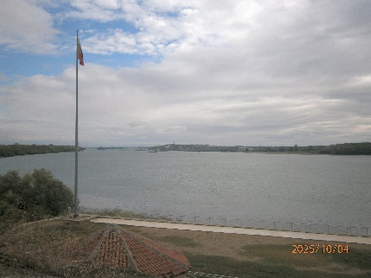
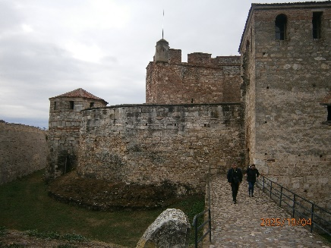
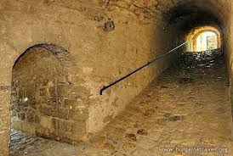
It was then time to climb back on the coach to go to Baba Vida Fortress. The Baba Vida fortress is the main landmark of Vidin. It is the only medieval fortress that’s been preserved in its original form. It is located on the great bend of the Danube River in the city, with a view of a bridge linking Romania with Bulgaria. The fortress served as the main defensive installation of Vidin during the Middle Ages and acted as the most important fortress in northwest Bulgaria. Legend has it, Vida was the eldest daughter of a Bulgarian boyar (a member of the old aristocracy in Russia) with vast possessions. Taught by the failed marriage of her sisters, Kula and Gamza, she rejected all marriage proposals, built an inaccessible castle, and spent her entire life there, a medieval version of the concept of the Iron Maiden. It is accessed by a steep and slippery tunnel with uneven stones. Baba Vida is now the summer theatre of Vidin.
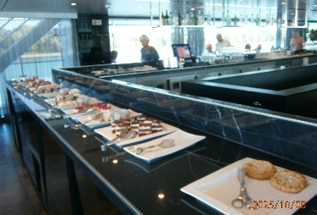
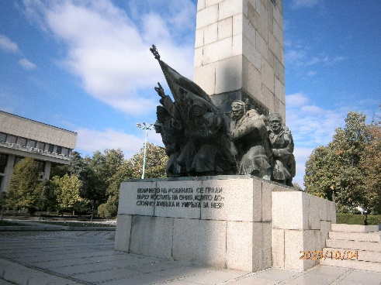
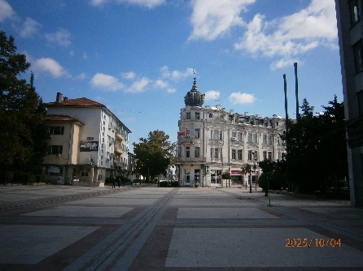
After lunch Elaine and I joined a walking group to the town centre. It was a nice gentle stroll in the sunshine. The town was empty of people. We were told that at weekends they go to the family home in the country, which is passed down through the family. Many are in dire need of TLC. Elaine & I went in the few shops that were open, just to compare prices. A nice pair of shoes could be bought for approximately 20euros. Elaine said Barbie dolls were half the price of UK prices as were leather handbags.
We were then back on board in time for afternoon tea as if we needed anymore food! The coffee was welcome though.
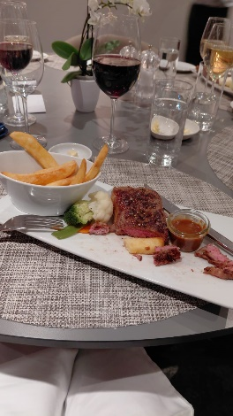
We had our afternoon talk on the following days’ programme, then it was the rush to get down to the dining room. I left the talk e few minutes early to go to the loo and went straight down to the dining room to reserve our usual table.
No sooner had I sat down, much to my surprise, Brian, our waiter came with a dish of margarine for my bread. That is service! My choice this evening was mushroom risotto without the cheese, followed by medium rare sirloin steak, which came with al dente vegetables and hot, crispy chips. Dessert, I left to Brian. I was served with a chia seed pudding. Not something I would have chosen, but it was nice.
After dinner, the 5 of us went up to the lounge for a quiz with Izzy. We didn’t do too badly the top scoring team got 30, we got 25. We had to put what the correct words were to a song, or what happened next in a film clip. It was good fun and made us think.
Our clocks go forward 1 hour tonight to Central European Time, as we cross into Serbia.
5th October Sunday
I was woken at 04.15am as we went through a lock. It was quite noisy, and I couldn’t get back to sleep, so I got up in search of coffee. There were a few of us prowling around.
Just as I was finishing breakfast, we started going through the iron gate gorge. It was cold and windy, but worth being on the “sun deck” for. There is a lot of history to the gorge.
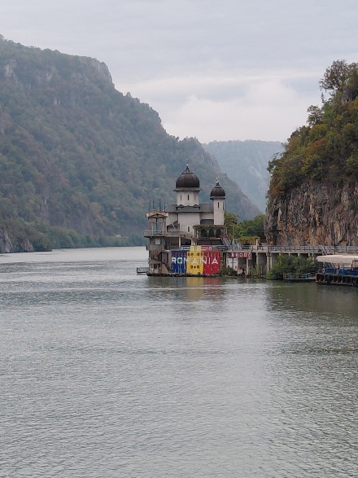
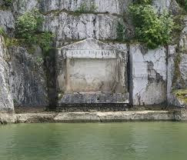
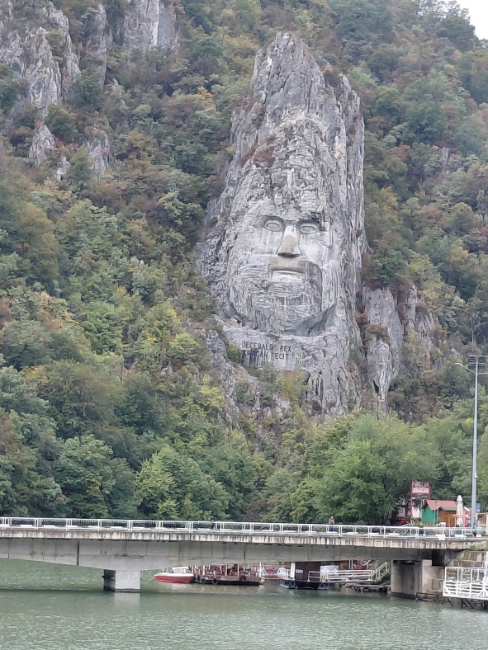
Iron Gate, is the last gorge of the Ðerdap gorge system on the Danube River, dividing the Carpathian and Balkan Mountains and forming part of the boundary between Serbia and Romania. It is about 2 miles long and 530 feet wide, with towering rock cliffs that make it one of the most dramatic natural wonders of Europe. In the 1960's, the government built a massive lock and dam to help control the speed of the river and make navigation safer. Before the Danube River was dammed, commercial boats transferring goods dreaded navigating the rapids of the narrow Iron Gates section of the river. After completion of the dam project, the river flowing through the Iron Gates calmed and the water rose 130 feet higher than before the dam and power station were built. The two locks, spread more than 50 miles apart, anchor each end of the Iron Gates and the impact of the dam could be felt for over 100 miles; over 23,000 residents living along the river needed to be resettled after the dam was completed. The Tabula Traiana is a Roman memorial plaque carved into a cliff face on the Serbian side of the Iron Gates gorge on the Danube River. It commemorates the completion of a military road built by Emperor Trajan to support campaigns in Dacia and is dedicated to him. The inscription, which mentions Trajan's achievements, is now located at a higher altitude due to the construction of a hydroelectric power.
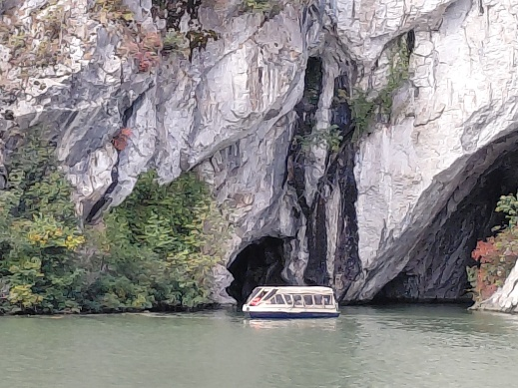
At the border between Romania and Serbia, on a rocky bank of the Danube, is Europe’s largest rock sculpture, the face of Decebalus. Measuring 55 meters in height, the colossal carving takes the breath of any visitor due to its sheer size and grandeur. Decebalus, the last king of Dacia, is considered a national hero. Fighting with his all might against the Roman Empire and securing the region of Dacia against all threats, he was a king respected and admired during his time and well after. Europe’s tallest rock sculpture stands as living proof of this.
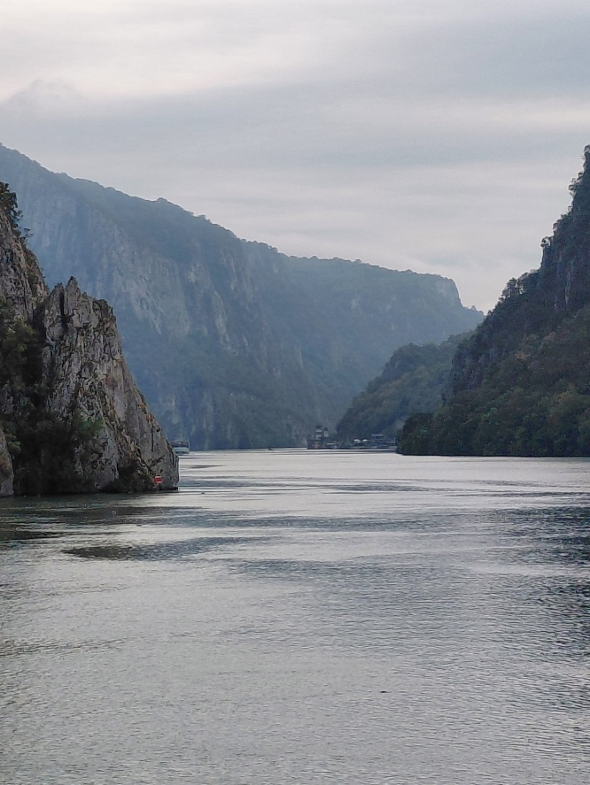
Numerous caves line the rock walls of the Iron Gates of the Danube River separating Romania and Serbia. The largest cave, Ponicova, is located near Dubova Town and is also known as Water Mouth Cave and Bat’s Cave. During cold War communist times: the cave connected Romania with the Danube and was a good hiding place for those who wanted to run by swimming to Serbia. Both caves are home to bats and butterflies, and only accessible by boat.
We moored at Golubac in Eastern Serbia, and after the ship had passed through customs, we were allowed ashore, provided we had collected our passports, as Serbia wasn’t in the EU. We were taken by coach to the Lepenski Vir archaeological site in the Derdap National Park.
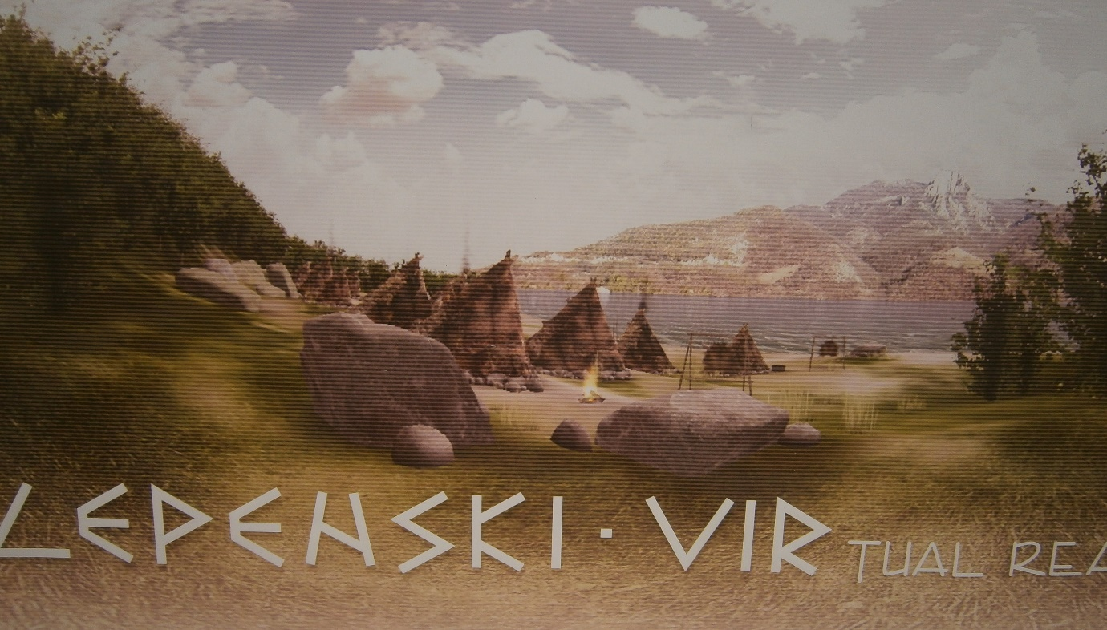Lepenski Vir, a Paleolithic site on the banks of the Danube, is proof that the local culture developed social relations, architecture and art more than six thousand years ago, and is one of the largest and most significant prehistoric archeological sites from the Stone Age.
Rich cultural layers reveal the traces of highly developed culture that had complex social relations and as such was the first in Europe to organize its settlement according to a plan.
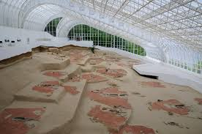
During the archaeological excavations seven stages in the construction of the settlement and 136 buildings were discovered. The settlement was built on the loessial terraces facing the Danube, the river that gave them life and at the same time seemed divine and awe-inspiring.
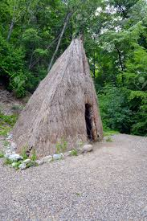
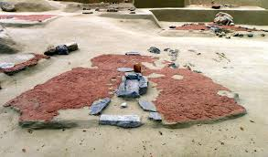
The characteristic of this settlement were the trapezoid-base houses with primitive wooden construction which were organized in the shape of a horseshoe. The buildings surrounded an open space – the first known square, with the central building, probably some kind of a temple or a shrine. A fireplace surrounded with fishlike stone figurines took central place in every house.
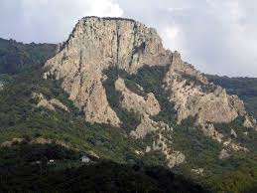
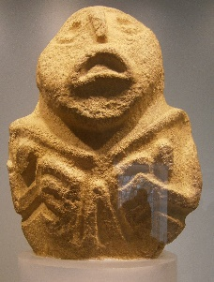
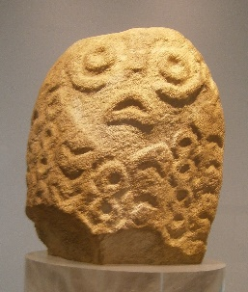
Stone idols found in Lepenski Vir represent the oldest monumental stone sculptures found in Europe. Besides these figurines numerous tools and arms made of stone, bone and antler, pottery and jewellery made of shells and pebbles were found here. Based on this evidence they can conclude that these first inhabitants of the Danube banks lived at the time of the Neolithic revolution, when the first communities started working the land and tamed some animals.
The access to the site was lined with medicinal plants, and opposite the site across the river was a mountain, said to have been sacred to the inhabitants.
Our next stop was either the ship or Golubac Fortress. I had chosen to the extra tour of the fortress.
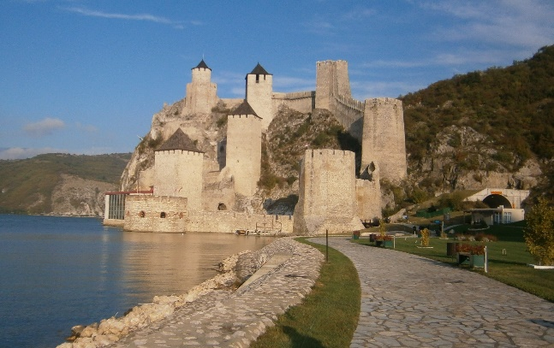
Golubac Fortress was built at the entrance of the Iron Gate gorge, a place where the Danube’s widest stream flows into a pass of the Carpathian Mountains. The Fortress represented an important military border stronghold, built purposely in response to the military and strategic significance of the area. The position of the fortress allowed easy control over all roads and waterways connecting the east and the west, while the steep and inaccessible Ridan cliffs on which the fort was built, as well as the Danube River, provided natural protection. Such position led the border powers – Hungary and Serbia, and later the Ottoman Empire, to battle throughout the 14th and 15thcenturies in order to conquer the Golubac Fortress and gain control and dominance over the state border.
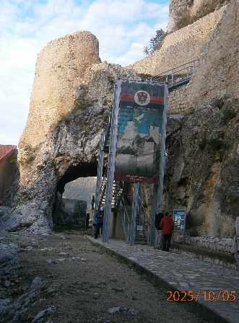
The explanation for the mystery of the name is found in medieval legends, among which the most famous one tells the tale of an Ottoman town commander who fell in love with a beautiful local girl named Golubana. Having refused to enter his harem, Golubana was cruelly punished – she was chained to a rock to repent. Her defiance to the Ottoman commander led to her death. In her memory the Fortress was named Golubac, while the rock, which she was tied to, protrudes from the Danube to this day, was named “Baba-kaj” (Turkish for “repent”).
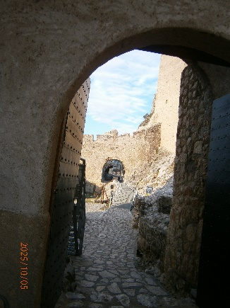
In the 1930s, construction of a regional road that ran through the Fortress caused damage to both gates of the fortification. It wasn’t until the 1970s that the country’s researchers focused their interest on the fortress, prompted by the construction of hydropower plant “Djerdap I”.
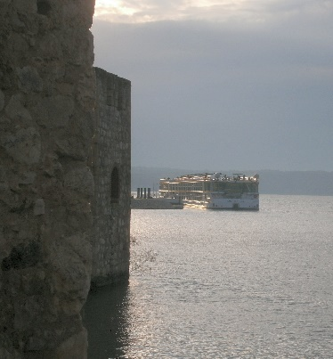
Our guide said that high sided vehicles used to get stuck under the arches, and that he often got stuck in the fortress overnight because 2 vehicles had become wedged in the tunnels. It was a two-way street, but barely wide enough for one vehicle.
Then, even though they are not part of the EU, they were given money to build a series of tunnels around the fortress, and the fortress was then restored.
Back at ship, which I could see from the fortress, I changed my shoes and went to the lounge for a coffee.
After dinner, I went back up with Peter, Elaine, Jim & Pat for Izzy’s quiz, which was on films. (naming the tune, naming the voice etc). We didn’t do very well at all. I think we were all tired, I certainly was. As soon as the quiz finished, I sought my bed.
6/10/25
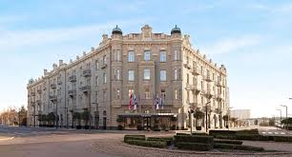
I woke, stretched, showered & went up for breakfast. I was an hour late! It was a mad dash to grab my passport and jacket and get to the coach for the days trip into Belgrade.
On our way to the fortress of Belgrade, we passed some beautiful buildings including the Hotel Bristol.

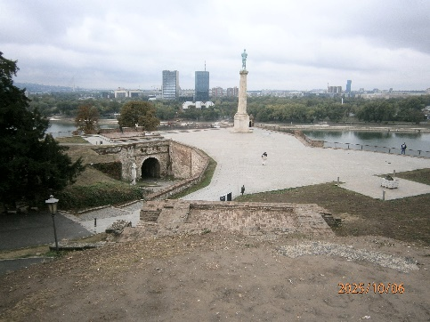
The Belgrade fortress, built on a white ridge above the confluence of two big rivers, destroyed and rebuilt over and over for 16 centuries, stands as the symbol of Serbia’s capital.
The “Victor” monument– victor over time, oversees the rivers and guards the riverbanks.
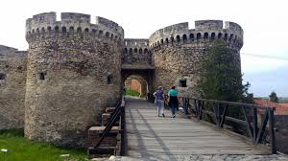
The Belgrade fortress was built during a long period of time from the 2nd to the 18th century. Destroyed and rebuilt numerous times, the fortress has become the symbol of the city that keeps raising and growing. Armies, people and conquerors have left their mark, hence the historical layers that were left by Romans, Serbs, Turks, Austro-Hungarians lying one beneath another.
The Romans had built the first fortification in the 2nd century and later it was home to the Roman legion IV Flaviae which protected the area. It suffered devastation by Goths, Huns, Avars and Slavs. Sometime during that tumultuous time, the ancient Singidunum was created. It was erected on the very same white ridge after which it was named “Beo-grad” (white-city).
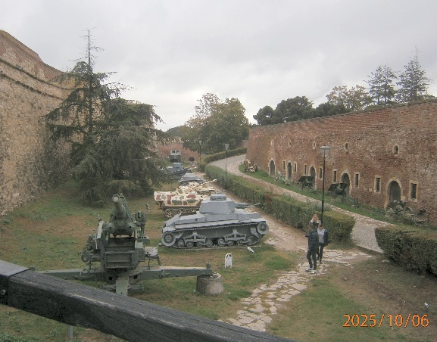
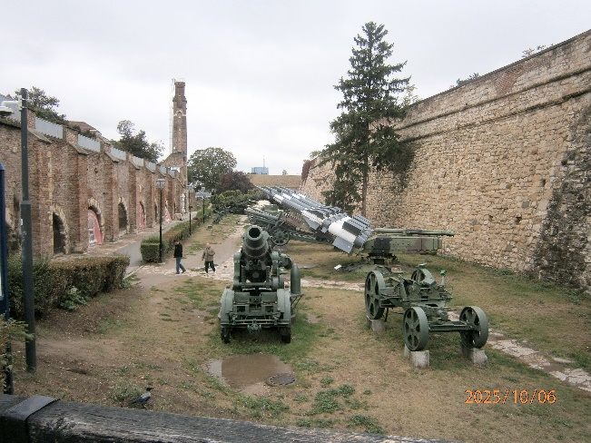
Today the Belgrade fortress comprises of Upper and Lower Town and the vast field in front the very fortress that Turks named “Kalemegdan”, joining the words “kale”, which means city, fortress and “megdan”, the Turkish word for field. The most beautiful and most spacious park in nation’s capital once used to be a field where battles were fought with enemies.
Beneath every footstep made in the Belgrade fortress lies more history than it can be found in history books. The so-called “Roman well” that was actually built in the early 18th century hides numerous stories. Most of the gates leading into the city are preserved, as well as the Sahat tower (Clock tower) that still today looks like it looked the day it was built.
There was so much history imparted by our very enthusiastic guide. It was hard to take it all in. The moat is now home to tennis courts, a children’s play park, as well as a museum of tanks, canon and other weapons of war. The panoramic views from the fortress are breathtaking. Standing on the ramparts, we had a spectacular view of the confluence of the Sava and Danube rivers, as well as the cityscape of Belgrade. Kalemegdan Park, surrounding the fortress, is a beautiful space with well-maintained gardens, walking paths, and plenty of spots for picnics and relaxation.
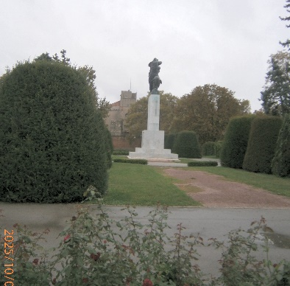
The Monument of Gratitude to France, was erected at the end of the main alley of Kalemegdan Park in 1930 as a symbol of friendship and cooperation between Serbia and France during the World War I. The Monument was built with the donations from the Friends of France and the Association of French Schools Alumni. The monument represents a bronze female figure, symbolizing France, rushing to the aid of Serbia. France took in many Serbia refugee children.

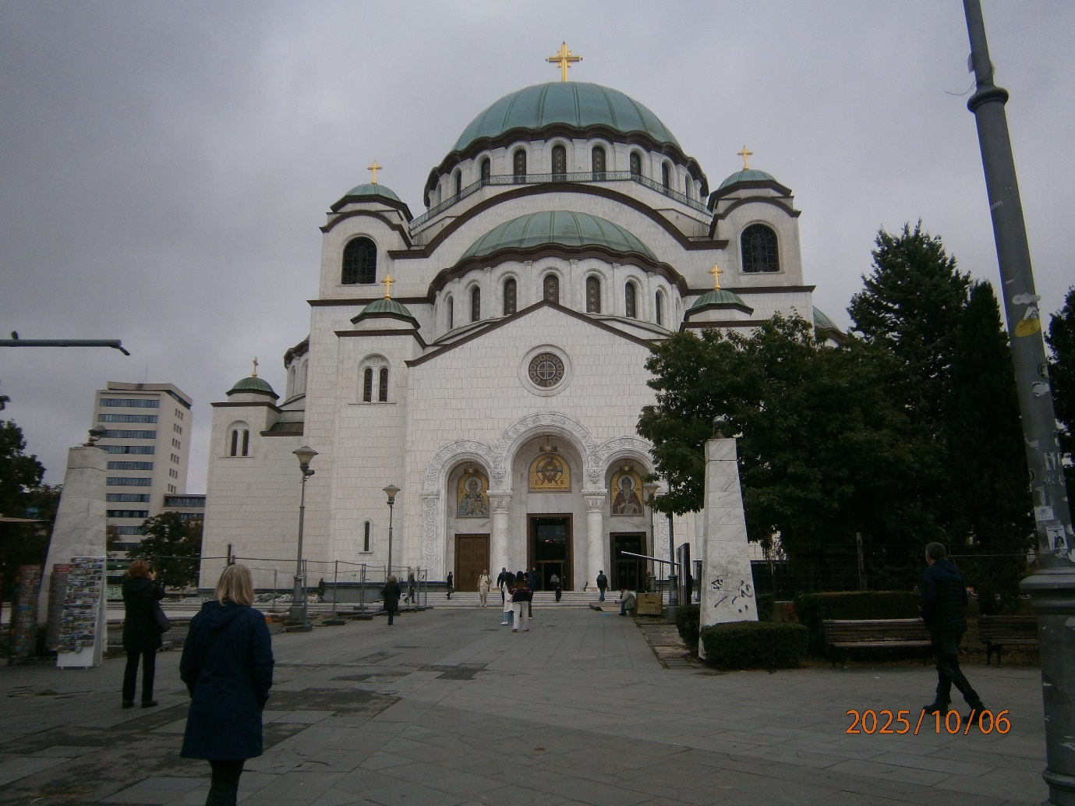
Our next stop was the church of St. Sava. The former Yugoslav capital is home to one of the largest Orthodox churches in the entire world. The church of Saint Sava is the second largest, the first being in Saint Petersburg, Russia.
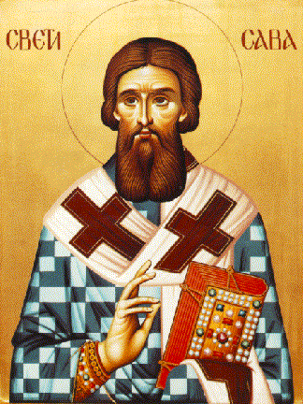
The church is dedicated to one of the most fascinating individuals in Serbian history – the founder of the Serbian church.
Sava, born Rastko Nemanjić, was the son of a Serbian king, Stefan Nemanja. His fairytale-like life story is everything but boring. Even though he was destined to lead a life of riches and abundance, Rastko had a different idea in mind.
As a teenager, he gave up his crown and escaped at night to Greece’s Mt. Athos. There he became a monk, decided to live in modesty and accepted a new identity by taking the name Sava. Sava was remembered for dedicating his entire life to the Serbian church and people and their well-being.
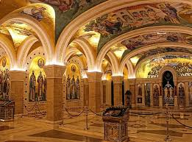
The church’s history is fairly long and turbulent. A lot of ups and downs and complex conditions got the church to the stage that it’s in today – magnificent, but still unfinished. The exterior was completed in 2004. The church’s facade is covered in smooth white marble and granite and topped with several copper domes.
The construction board for the church was established in 1895, but the construction didn’t begin before 1935. Even after that, the road wasn’t at all smooth, since it was followed by World War II and then existence in Communist Yugoslavia.
Only a couple of years after the beginning of construction, German forces bombed Belgrade in World War II. The work on the church was halted. In addition to that, one of the most humiliating things that happened was the fact that Germans used the church as their storage space and their parking lot.
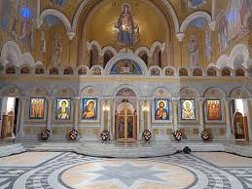
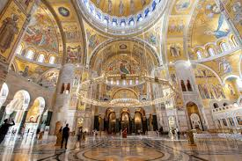
However, even after Serbia was liberated, there was a new bump in the road – the Yugoslav Communists. They actually ended up stopping the construction for another 40 years, which is one of the reasons the church is still unfinished today.

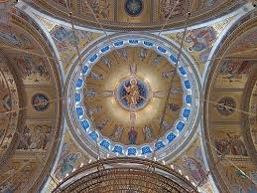
The Communists were openly very anti-religion, since they firmly believed in Marx’s quote that “religion is opium of the people”. Therefore, after they came to power in Yugoslavia, they wouldn’t give the church building back to the church until 1984.
However, there’s one internal section that is completely finished; The 1800 m² magnificent crypt located 7 meters below the actual church. Its walls are covered in hundreds of incredible frescoes, and the ceiling is covered in gold and the most stunning chandeliers. It is a WOW! Moment.
The mosaic tiles are made of a glass sandwich, with the colour as the filling. The tiles are not smooth, which gives the shimmering reflections.
There is no organ or seats. The services are chanted, and worshipers stand the entire time, usually for 1 hour, but for Christmas and other celebrations it can be as long as 3hours.
Inside the crypt, are the spaces reserved for the future graves of patriarchs. There are also plans to transform one section of the crypt into a concert hall of sorts, for religious music performances and gatherings.

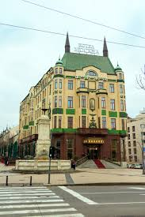
Leaving this amazing building, we climbed aboard our coach and were taken a short ride to The Hotel Moskva (Moscow) for coffee and cake.
Hotel Moskva, the architectural jewel of Russian secession, forever changed the impression of Belgrade and soon became the meeting spot of Belgradians, Balkans and the world elite.
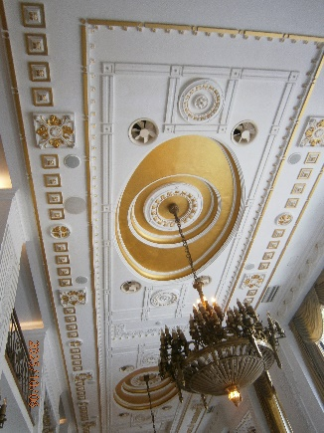
Opened in1908, inaugurated by King Petar I Karadjordjevic personally, it was known as the place where the history of this part of the world was created. It outlived two World wars, eight state systems and became the most prominent symbol of Belgrade and the greatest charmer of the hospitality scene. If only the walls of palace Moskva could talk, they would tell great stories about everlasting love, diplomatic strategies and negotiations, inspirational artists, Nobel Prize winner writers, royal events, all night long conversations… Maybe they would reveal many secrets, heard during the last 114 years.
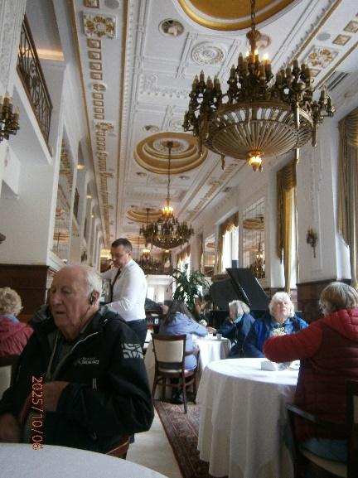
Moskva café and pastry shop is one of the oldest and best known in this part of the world, is a meeting point of Belgrade people of all ages. Its pleasant atmosphere, old charm and high hospitality standards are a perfect escape from the crowds and a place to relax and unwind with a grand piano being played for accompaniment.
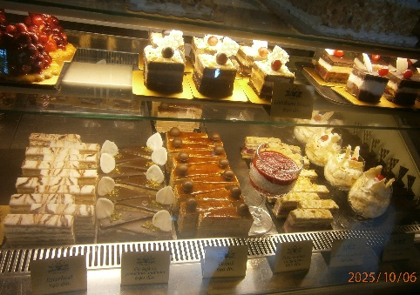
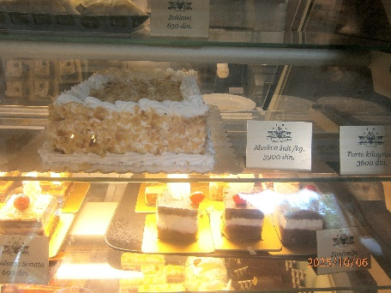
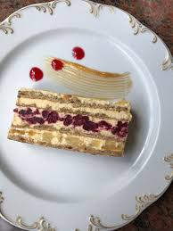
Moskva Schnitt (our cake) is a recognizable and protected brand of the hotel Moskva pastry shop, established over 40 years ago. When in 1974 Cafe Moskva was opened, inspired by a new concept and new ideas, Mosvkva Schnitt cake was just one of many recipes created that year, but it was this cake that became World famous within just months. Since then, Moskva Schnitt cake is served to around 300 people daily, and the hotel's pastry shop delivers around 1.000 whole Moskva Schnitt cakes to various addresses. Summing up those amounts up Moskva pastry shop makes 20 tons of Moskva Schnitt cake a year. The main ingredients are almonds, cherries, pineapple and finest, top-secret homemade cream.
(it is about £7 per slice)

Returning to the ship it was time for lunch!
I enjoyed Asian noodles, followed by a chicken salad.
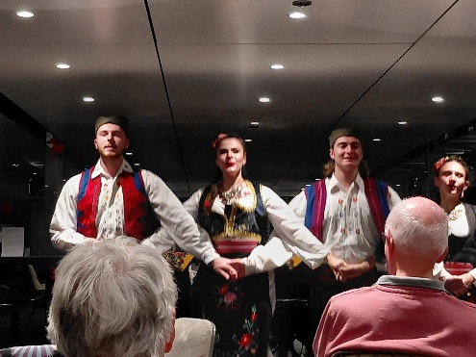
The afternoon was spent resting and catching up with my diary, while the more fit and energetic passengers went for a bike ride.
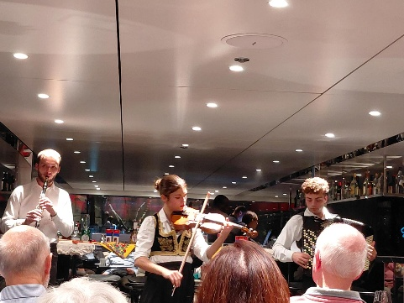
After dinner, we were entertained by a Serbian folklore group. It was very interesting with a mix of Turkish, Greek and Russian dance styles.
7/10/25 Tuesday
Even though the ship sails mainly at night, I quickly got used to the noises and movement, and had a good night’s sleep, waking in time for breakfast.
We briefly had blue skies this morning, which was lovely.
After breakfast, (which is getting smaller as the week went on) we had to assemble in the lounge for a talk about going home ~ already. We don’t go until Thursday (and its only Tuesday!)
Today we have a walking tour of Vukovar, which is in Croatia. Vukovar’s darkest chapter in history was during the early stages of the Yugoslav Wars of the 1990s
The Battle of Vukovar was the first large-scale military confrontation in Europe since WWII. It was also the beginning of the atrocities and war crimes that came to characterize the conflicts in the Balkans. Today, Vukovar has more memorials and other war-related sites than any other single place in Croatia and it is a prime “dark-tourism” destination.
Since the war, many properties have not been repaired, instead standing as a lasting reminder.
During WWII Vukovar was part of the Independent State of Croatia, a Nazi puppet state run by the ultra-nationalist Ustashe regime. In Vukovar, the Ustashe massacred some 400-500 civilians – alleged communists, anti-fascists, members of the resistance or sympathizers with the partisans, the majority being Serbs – at a site on the southern edge of town called Dudik (which apparently means 'grove of mulberry trees') between 1941 and 1943. After that, all remaining prisoners of the Ustashe in Vukovar were transferred to the concentration camp of Jasenovac.
Vukovar was liberated in mid-April 1945 by the Yugoslav partisans, with some assistance from the Soviet Red Army. The town's civilian German population was then forcibly expelled and their properties given to Croats and Serbs as communist Yugoslavia was formed.
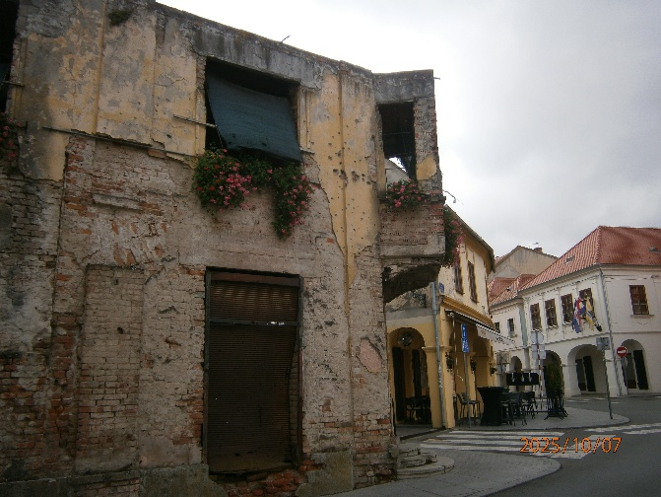
And then came 1991 and war returned. At the beginning of the break-up of Yugoslavia and with Croatia declaring its independence, tensions were rising high in Vukovar between the ethnic Croat and the ethnic Serb parts of the population. Barricades were erected between ethically different parts of town, and the first escalations of violence occurred.
This building, with bullet holes and geraniums, was once a pharmacy.
The town was under siege by the Yugoslav Army and Serbian paramilitary forces for 87 days, but in the end the under-equipped and outnumbered Croatian defenders lost and Vukovar fell into Serbian hands. By then large parts of the town and the surrounding settlements, industries and infrastructure had been destroyed.
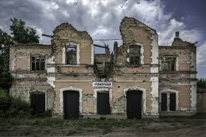
Vukovar remained in Serb hands immediately after the war but was eventually returned to Croatia in 1997. Only some of the exiled population have returned since, though, so that the population is still only just above half of what it had been before 1991. And many war ruins still remain: just left behind, unused, unneeded.
The former train station building near the harbour, is a badly battered ruin – though a very atmospheric one for those (like me) who appreciate beauty in decay. The old station received a new sign above the door in the centre, which looks incongruously clean and intact.
The Water Tower is a symbol of the three-month siege of Vukovar and also of the resistance and courage of the Croatian defenders, and a silent witness to the tremendous destruction and suffering in the Homeland War but also to the resistance, defiance and invincibility.
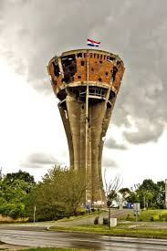
Given its imposing stature and the Croatian national flag fluttering defiantly atop of it each morning throughout the siege the aggressors targeted it daily, from all directions. Despite the 640 direct hits the Tower did not collapse but resisted the wounds and stood upright as if to say between the two explosions: “As long as I am here, the Town will be too”. Every night 2 young teenagers of Vukovar hoisted a new, undamaged Croatian flag on the top of the Tower and instilled new hope and strength in the people in Vukovar. The two teenagers defied the time, the fear, the cold, the shells, the enemy and made history.
The water tower, complete with holes, will remain a symbol of destruction and of resistance, of defiance and invincibility. The Vukovar Water Tower will be the only building in Vukovar to be left intact on the outside as an authentic witness of the tragic events in Vukovar and as a warning for the future. Incredibly, you can go up inside it. They have installed a lift, and a café inside the water tower, as well as a museum about the war.
Then we were on the coach to go and have lunch with a Croatian family. We passed flat lands planted with corn and sunflowers, and drove past an area of landmines, which cut the village off. It has only recently been cleared, and they are planting trees for fuel. Local people trying to escape the fighting, crossed the Croatian mountains. They took farm horses with them and used them to pick a path through the mine fields.
Many homes have been rebuilt, often using the ruins of the old house, or leaving the remains of the old house in the yard.
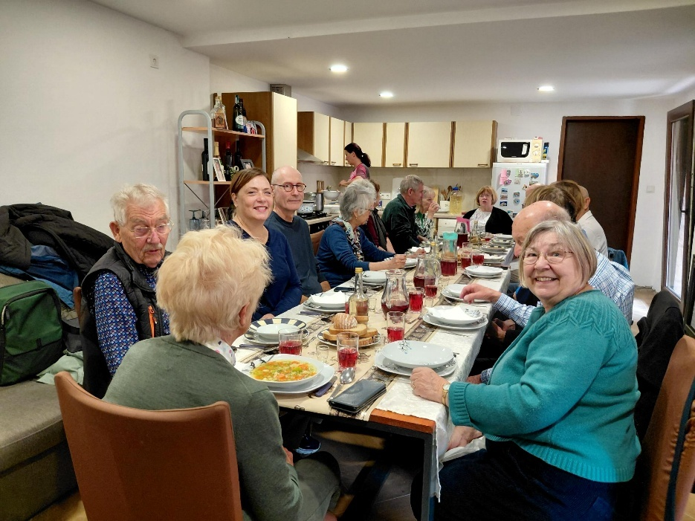
Each coach went to 2 destinations. I went to the home of Nada. Nada is Croation and married to a Bosnian, as were her parents. Nada came from Vukovar and was sent to stay with her grandparents. Her father took her back once to visit her mother, who was a nurse in Vukovar hospital. For 3 days she stayed in a building with no water or fuel, and wasn’t allowed out, so she asked to go back to her grandparents.
Nada told us about her life during the war. It was an emotional visit. Bringing home the awfulness of war, which most of were aware of but ignore because it didn’t affect us.
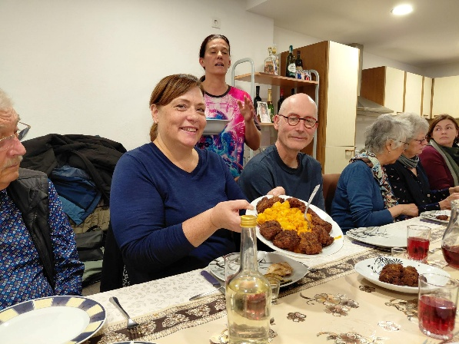
Nada has 3 jobs: providing lunches for cruise guests, cleaning in the evenings and cooking for others during the day. She has only been in her house 23 days!
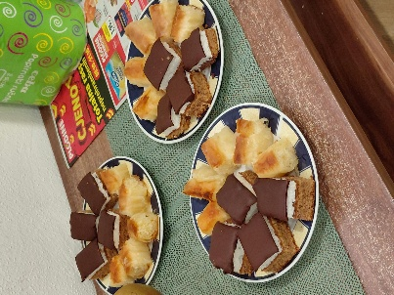
We had a lovely lunch. Vegetable soup and homemade bread to start with; followed by home-made rissoles of beef and pork, served with fried aubergine, mashed potatoes and carrots (she called them smashed). Home pickled peppers, & pickled cabbage. For dessert she had made little cakes- a type of baclava and an oaty coconut & chocolate square. We had home-made juice, and home-made apricot brandy. It was a lovely visit, and all too soon our coach was waiting for us to go back to the ship.
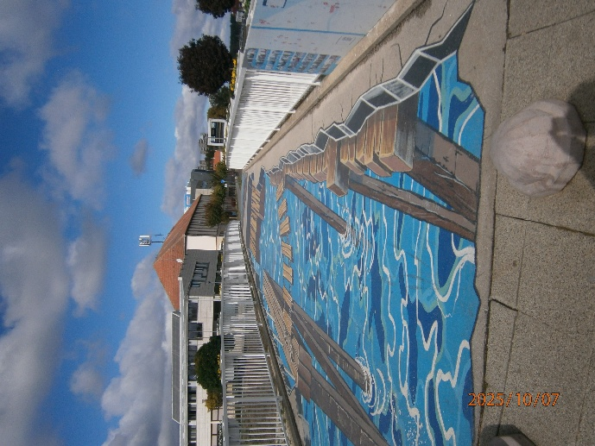
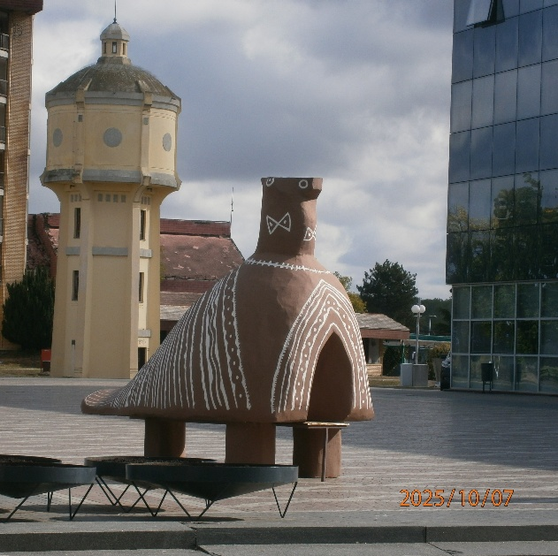
In the afternoon Izzy led a walk to the water tower. As nothing in life runs in a straight line; joys and sorrows; laughter and tears; ups and downs are intertwined, & the same is for Vukovar. The town met its calvary, but the experience did not break its spirit. Vukovar is like a phoenix rising from its ashes. It has new squares, hand painted bridges (It surprising how many people walked on the edge!) & statues to important people.
The Vučedol Dove, found at this site in 1938, has become a symbol of the town.
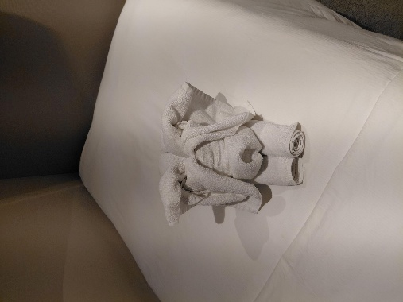
Dinner was preceded by the Captains farewell cocktail party, and a parade of all our staff on board ship. Our meal was beautiful, although none of us really liked the appetite teaser: - it was slightly fishy, but mushy. The steak was perfect. I had a special dessert, which was an apricot mousse on a dark chocolate biscuit crumb base.
Feeling overfull, it was time for bed, where I found another towel sculpture. I’m not sure if it’s a pig or a dog!

8th October
Hooray – Its sunny! After a much smaller breakfast (I’m beginning to feel overfed), we were off to a horse Farm at Puszta, Hungary, to learn about the Magyar cowboys. While waiting for the coach we watched the entire crew form a chain gang to reload with vegetables drink, and other provisions. They do work hard.
On the way to Puszta we stopped at Ordas, the home of Hungarian Paprika production & embroidery.
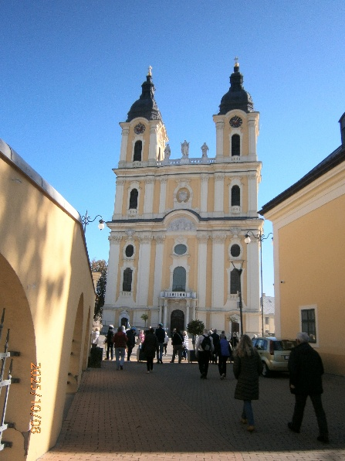
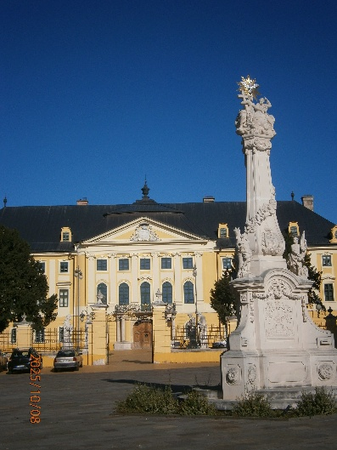
Ordas means place of the swamp, which is what it was before the Danube was regulated by dams in 1870’s. It is very flat land, and the Danube runs North to South. To the west are hills and mountains, and to the East it is flat agricultural land. Here they grow sweet peppers, which are turned into paprika. (There are over 100 sub types of sweet pepper) We visited the town of Kalocsa. The main feature of Kalocsa is St. Mary’s Cathedral: This Italian baroque cathedral sits in the center of town as part of the Holy Trinity Square. It is considered one of the most beautiful churches in Hungary. We couldn’t go in as it was shut. By its side were the ruins of its predecessor. It is also known as the Cathedral of the Assumption, and dates back to the 11th century. The church has a monumental organ, and it was first played by Francz Liszt.
Opposite is the Archbishop’s Palace. He lives in the left-hand side. The right-hand side is a huge library. The present-day library was established thanks to the efforts made by Adam Patachich. He was an Archbishop who left his private collection of approximately 19,000 volumes to the diocese.
The museum to Paprika was really a gift shop stocking huge bags of Parika. I would never use that amount in my lifetime. However, in the basement, it had a welcome toilet. (I hate the ones on coaches).
At the horse farm a few miles down the road, our coaches were met by the cowboys and escorted to the coach park. We were welcomed with tumblers of wine and slices of bread and dripping (pork) sprinkled with Paprika (it is the staple food of farming folk). – It was tasty.
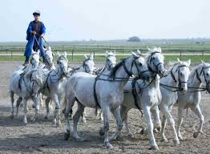
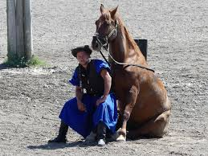
I managed to find a front row seat at an opening in the fence. The show was very entertaining. The saddles had no girths, so the riders were nearly bareback. We had displays of riding, resting, carriages and finished with a man standing in control of 10 horses. (He has actually broken the record by riding a team of 20).
It is also a working farm of about 200hectares, where they breed horses,” Raka” sheep and “mangalica” pigs. – All Hungarian breeds, which are protected by the Heritage program.
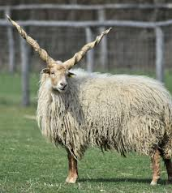
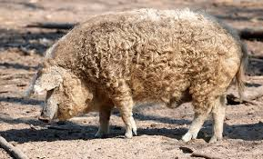
As we left, we were given a glass of Apricot brandy, before passing through the souvenir shop on the way back to the coach. I thought it was expensive, with a 1” x 2” bar of chocolate costing 2Euros. I didn’t buy any. So far, I have spent 45Euros on a trip round a castle, and 3 Euros on a coffee.
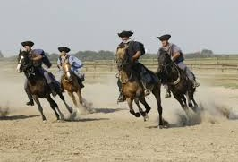
The sun has been out all day, and I had to drape my cardigan over my foot, as the sun was burning through my socks. At this point I regretted the 2 jumpers, thick cord trousers and jacket which I have lived in all week! Perhaps it is time to visit the sun deck of the ship when we get back.
The stables and horse farm used to belong to the Bishop in 1800’s. Then all property was taken by the communists, including the farm, where they bred cows for beef. In 1989/1990 Hungary became a democracy, and the farm was given back; and it opened as a tourist destination in 1995.
We had a typical Hungarian meal when we got back to the ship. I couldn’t have the pancake starter, so chose salad which was very filling. The main course was Hungarian goulash. (I didn’t enjoy mine much; the flavour was lovely, but my piece of meat was very sinewy) It was served on a bed of giant cous-cous. Dessert was a lovely dairy free Tiramisu.
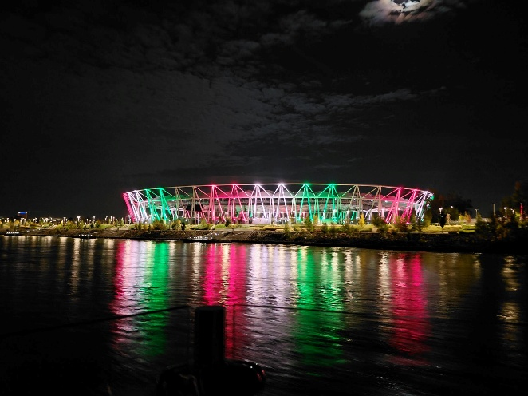
Due to low water levels, the ship had to travel slowly, which meant we would be too late to pick up our entertainment for the evening. Instead, the Captain decided to cruise a little longer so we could see Budapest by night. It was a wonderful way to finish our cruise.

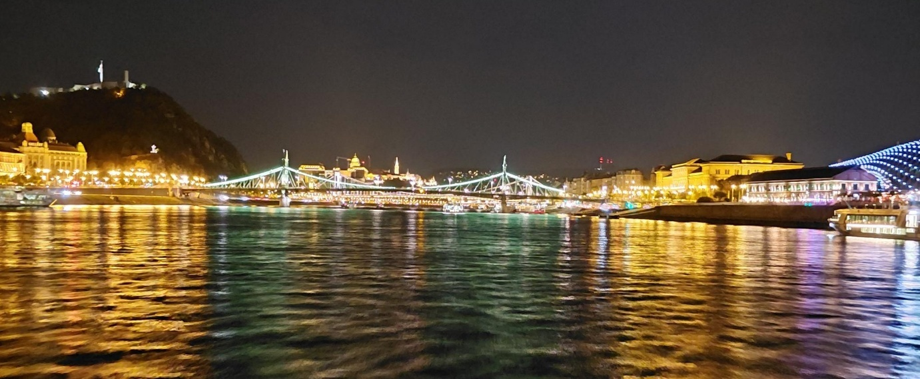
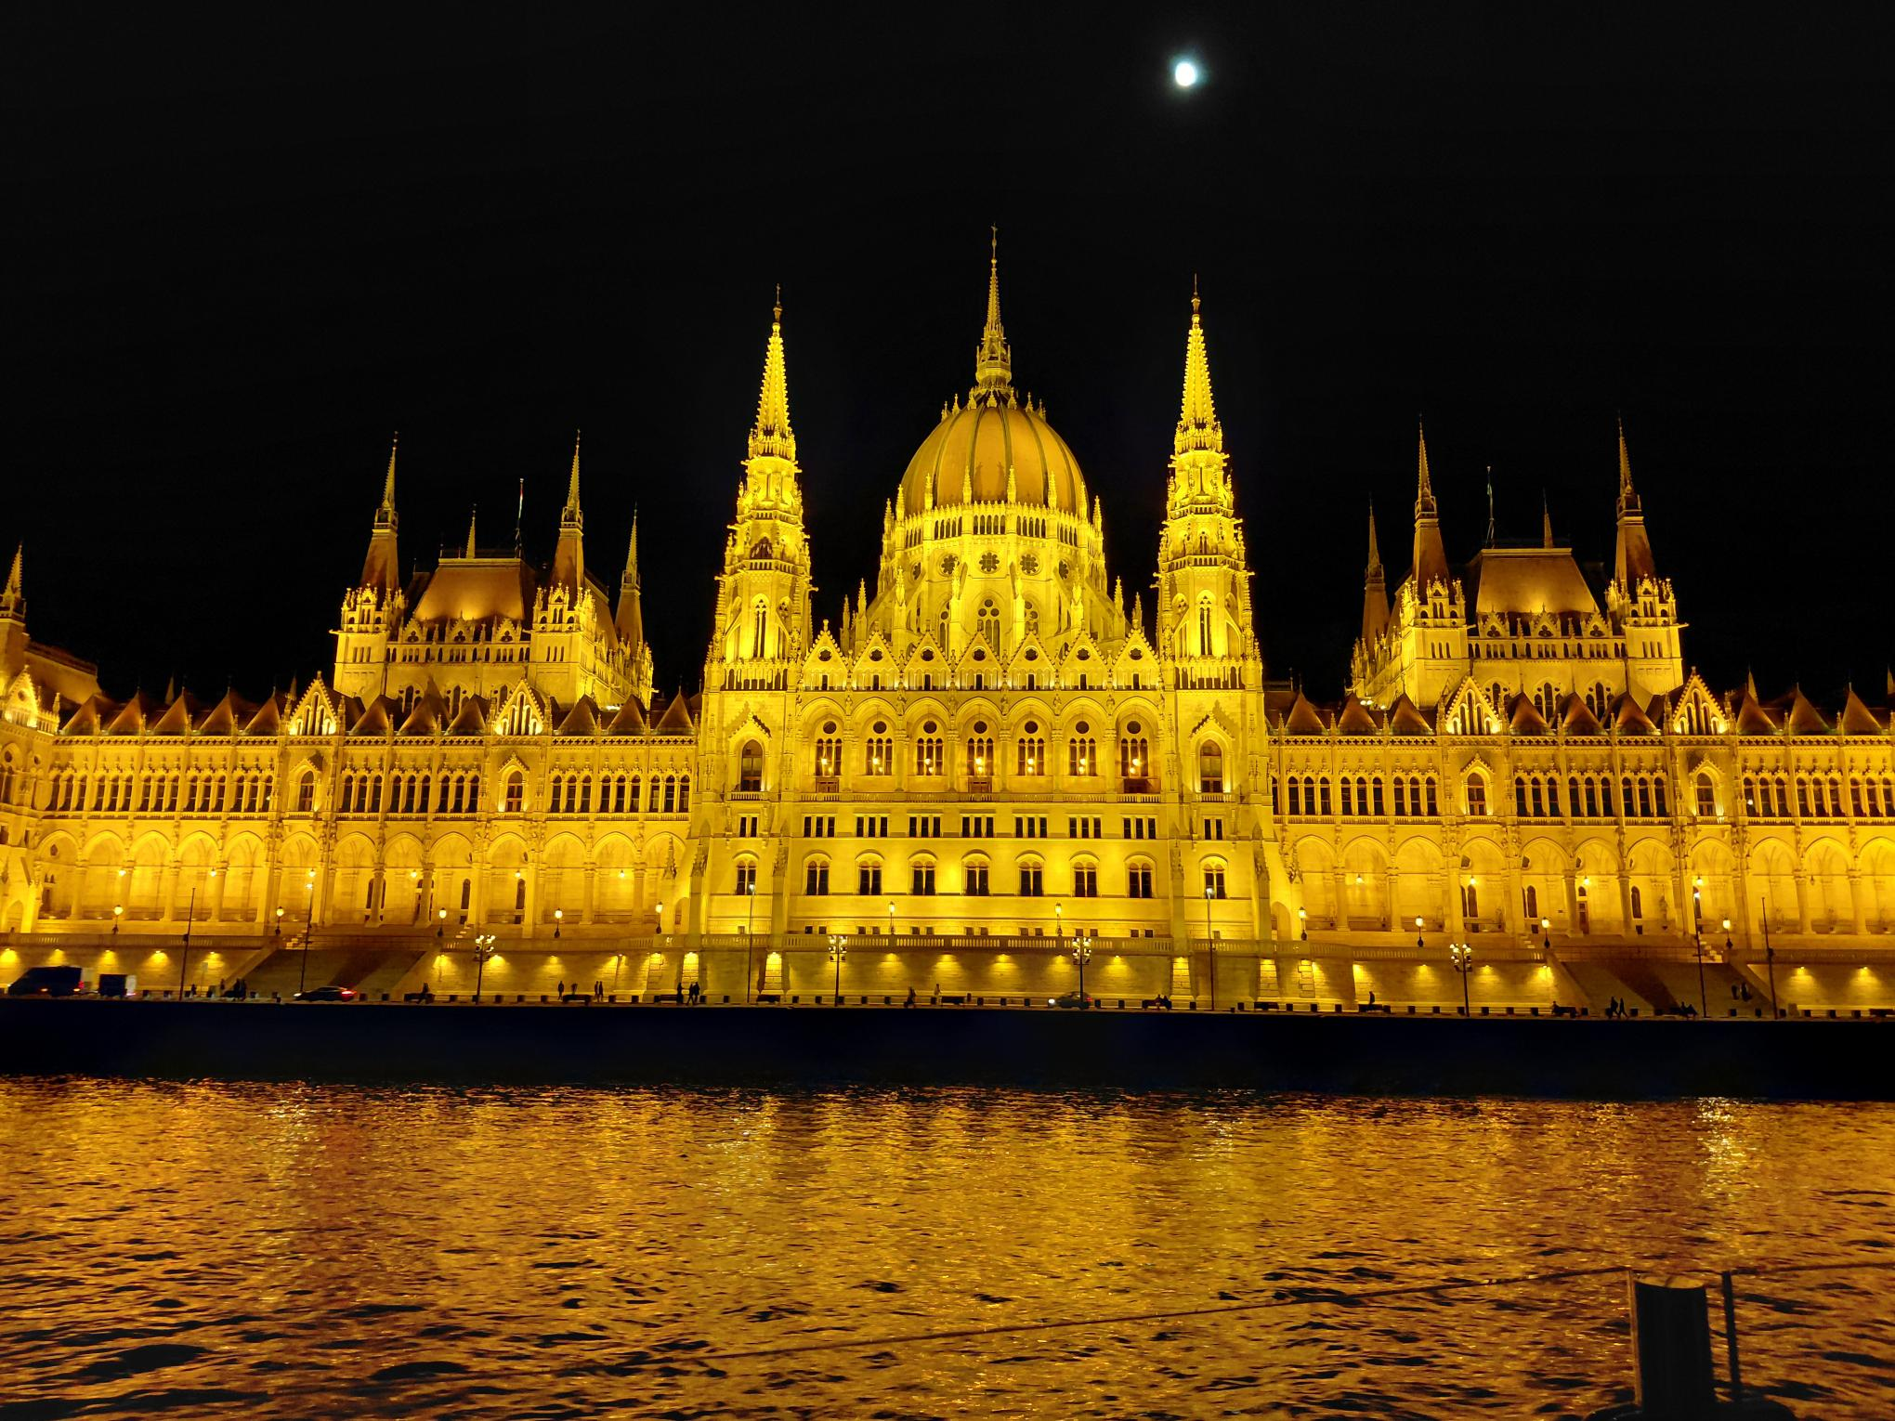
I still didn’t get to see the shoe memorial on the riverbank. Perhaps a 3rd visit is needed.
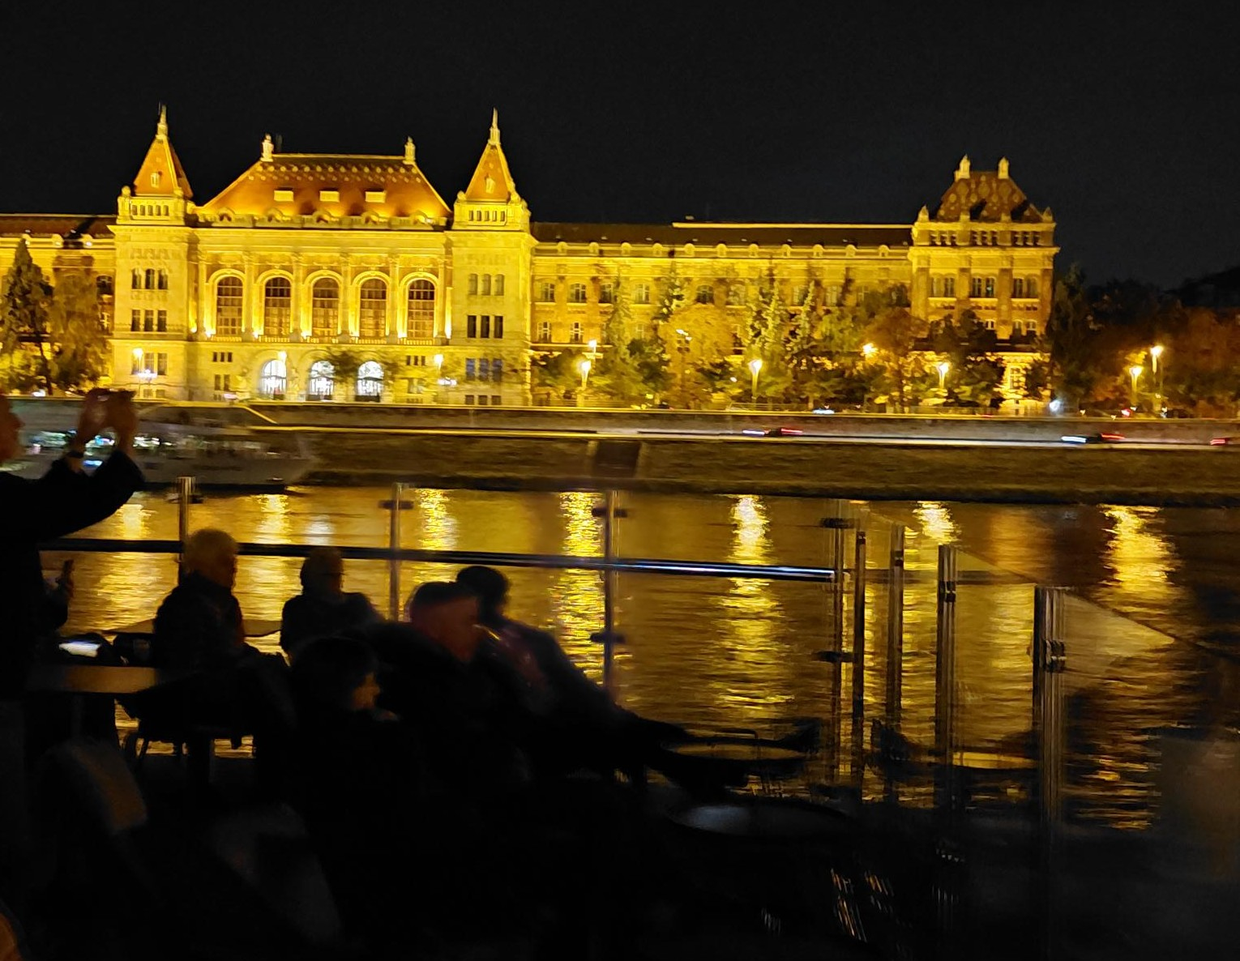

The ship: Luna Emerald, is much like most river ships, but with an indoor pool at the rear, which doubled as a cinema in the evenings.
- Launched:01 Jan 2020
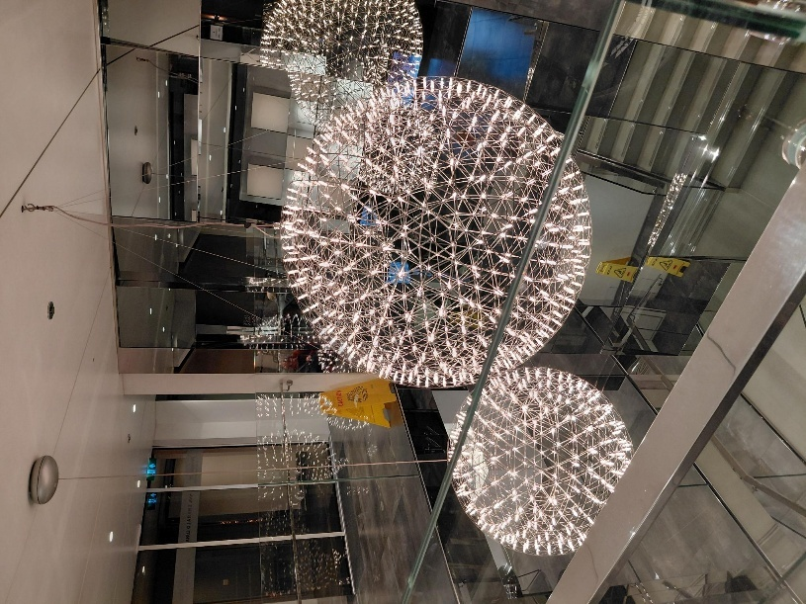
- Occupancy: 180
- Length: 135
- Total Crew 47

The food was amazing, as I had come to expect. As was the service. Our waiter, Brian was very attentive and had margarine on the table before I had finished sitting down. (I can’t have butter).
Desert choices I always left to him and had a surprise.

Typical evening meals
Starters
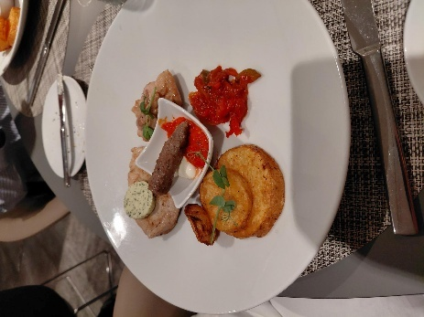
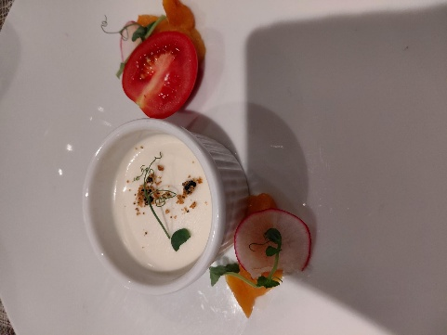
Goats cheese Egg plant & cheese rolls

Mains
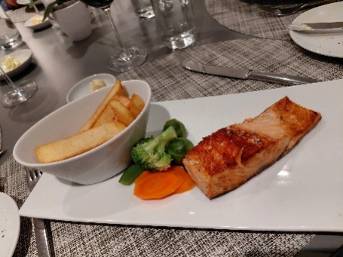
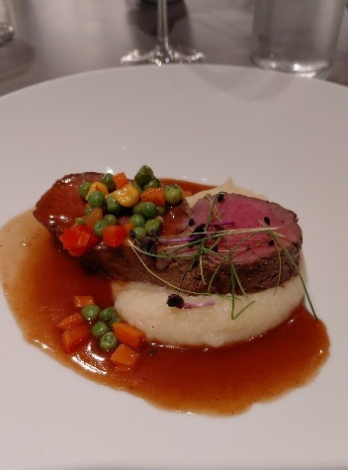
Salmon Steak

Desserts
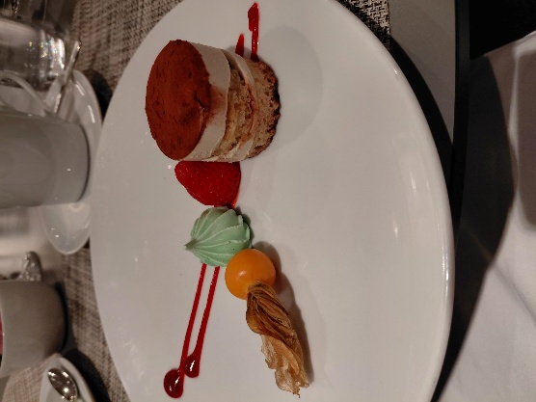
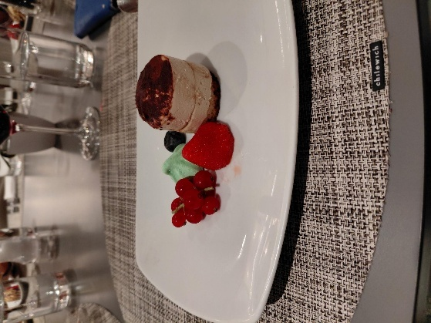
All dairy free

There was a menu each day with chef’s recommendations, but also other choices.
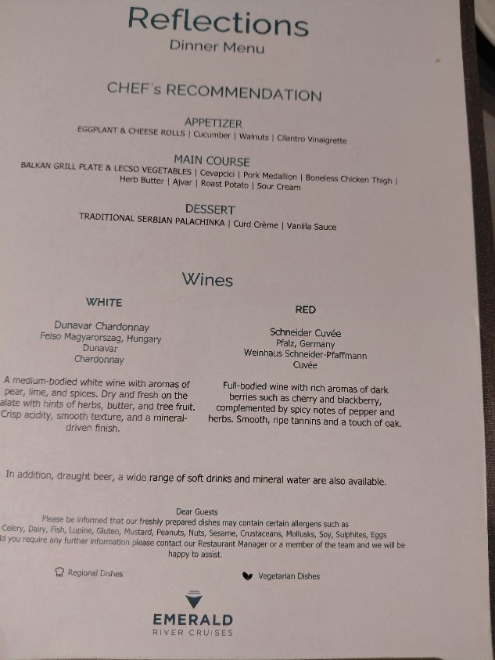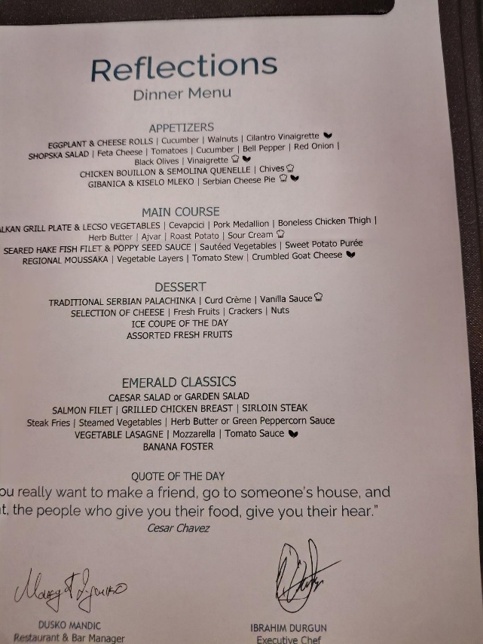

The daily program was on the tv in our staterooms, or on a sheet at the desk.
